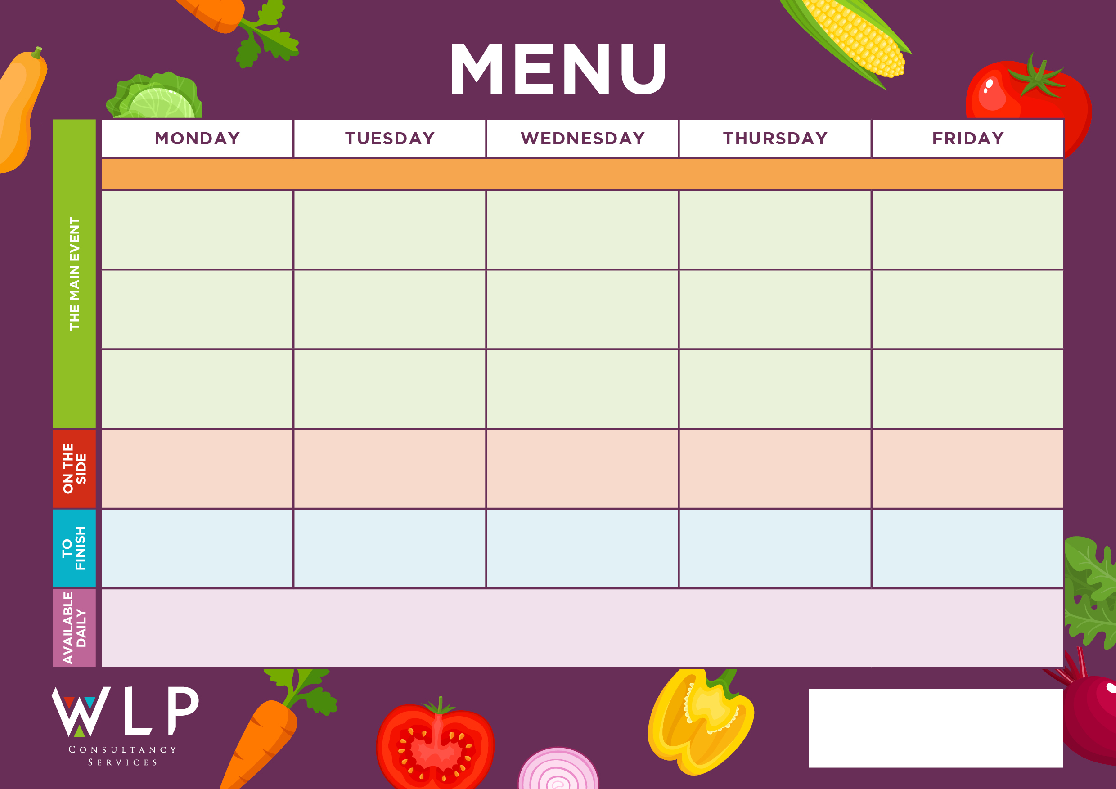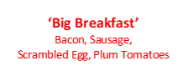



***‘Pizza Bar’***

Ham & Mushroom or

Cheese & Tomato. Vegan option available.

‘**Big Veggie Breakfast’**

with Mushrooms. Vegan option available

Vegetarian Sausage, Yorkshire Pudding & Gravy. Vegan option available

Jacket Potato with a selection of toppings.

Jacket Potato with selection of toppings

Chicken and Sweetcorn Meatballs

Chunky Chips

Penne Pasta

Baked Beans, Peas

Roast & Creamed Potatoes

Carrots

Cabbage

Strawberry Mousse with Mini Cookie

Oat Cookie

Fruit

Jacket Potatoes with a selection of toppings

Fishless Fingers

Fish Fillet or Fish Fingers

Chunky Chips

Penne Pasta

Baked Beans, Sweetcorn

Roast & Creamed Potatoes

Carrots

Cabbage

Grab bags, freshly made bread, selection of salads.

Fresh fruit, assorted yoghurts, are readily available as an alternative to dessert of the day.

Additional vegetarian & vegan options are available upon request. Vegan desserts available.

Chicken Burger in a Bap

**‘Big Breakfast’**

Bacon, Sausage,

Scrambled Egg, Plum Tomatoes

Roast Beef, Yorkshire Pudding & Gravy

Quorn Vegan Nuggets

Sweet & Sour

Pork Balls

Oat Cookie

Fruit Platter

Vegan Pasta with Crusty Bread

Quorn Lasagne with Garlic Bread

Cottage Pie

Toffee Mousse with Mini Shortbread

Vegan/Vegetarian Sausage

Vegetarian Gravy

Pasta

Sweetcorn

Peas

Chocolate Ice Cream or

Cookie

Hash Browns

Sweetcorn

Baked Beans

**‘Big Breakfast’**

Bacon, Sausage,

Scrambled Egg, Plum Tomatoes

Selection of Oven Baked Crispy Fish

**Myddle CE Primary School Menu Week 1– 6th Nov, 20th Nov, 4th Dec, 18th Dec, 8th Jan, 22nd Jan, 5th Feb 2024**

Iced Vanilla Sponge

Vegan Meatballs

Jacket Potato with a selection of toppings

Jacket Potato with a selection of toppings.

Oven Baked Crispy Fish Fingers

‘**Big Veggie Breakfast’**

with Mushrooms

Vegan/Vegetarian Fishless Fish-fingers

Vegetable Bake Burger

Roast Beef, Yorkshire Pudding & Gravy

Pork & Carrot Meatballs

Coconut & Orange Cookie

***‘Pizza Bar’***

Ham & Mushroom Or

Cheese & Tomato

Selection of freshly baked Muffins

Jacket Potato with a Selection of Toppings, Grab bags, Freshly made bread, selection of salads. Fresh fruit, assorted yoghurts,

are readily available as an alternative to dessert of the day.

Additional vegetarian & vegan options are available upon request. Vegan desserts available.

Herby Diced Potatoes

Mixed Vegetables

Baked Beans