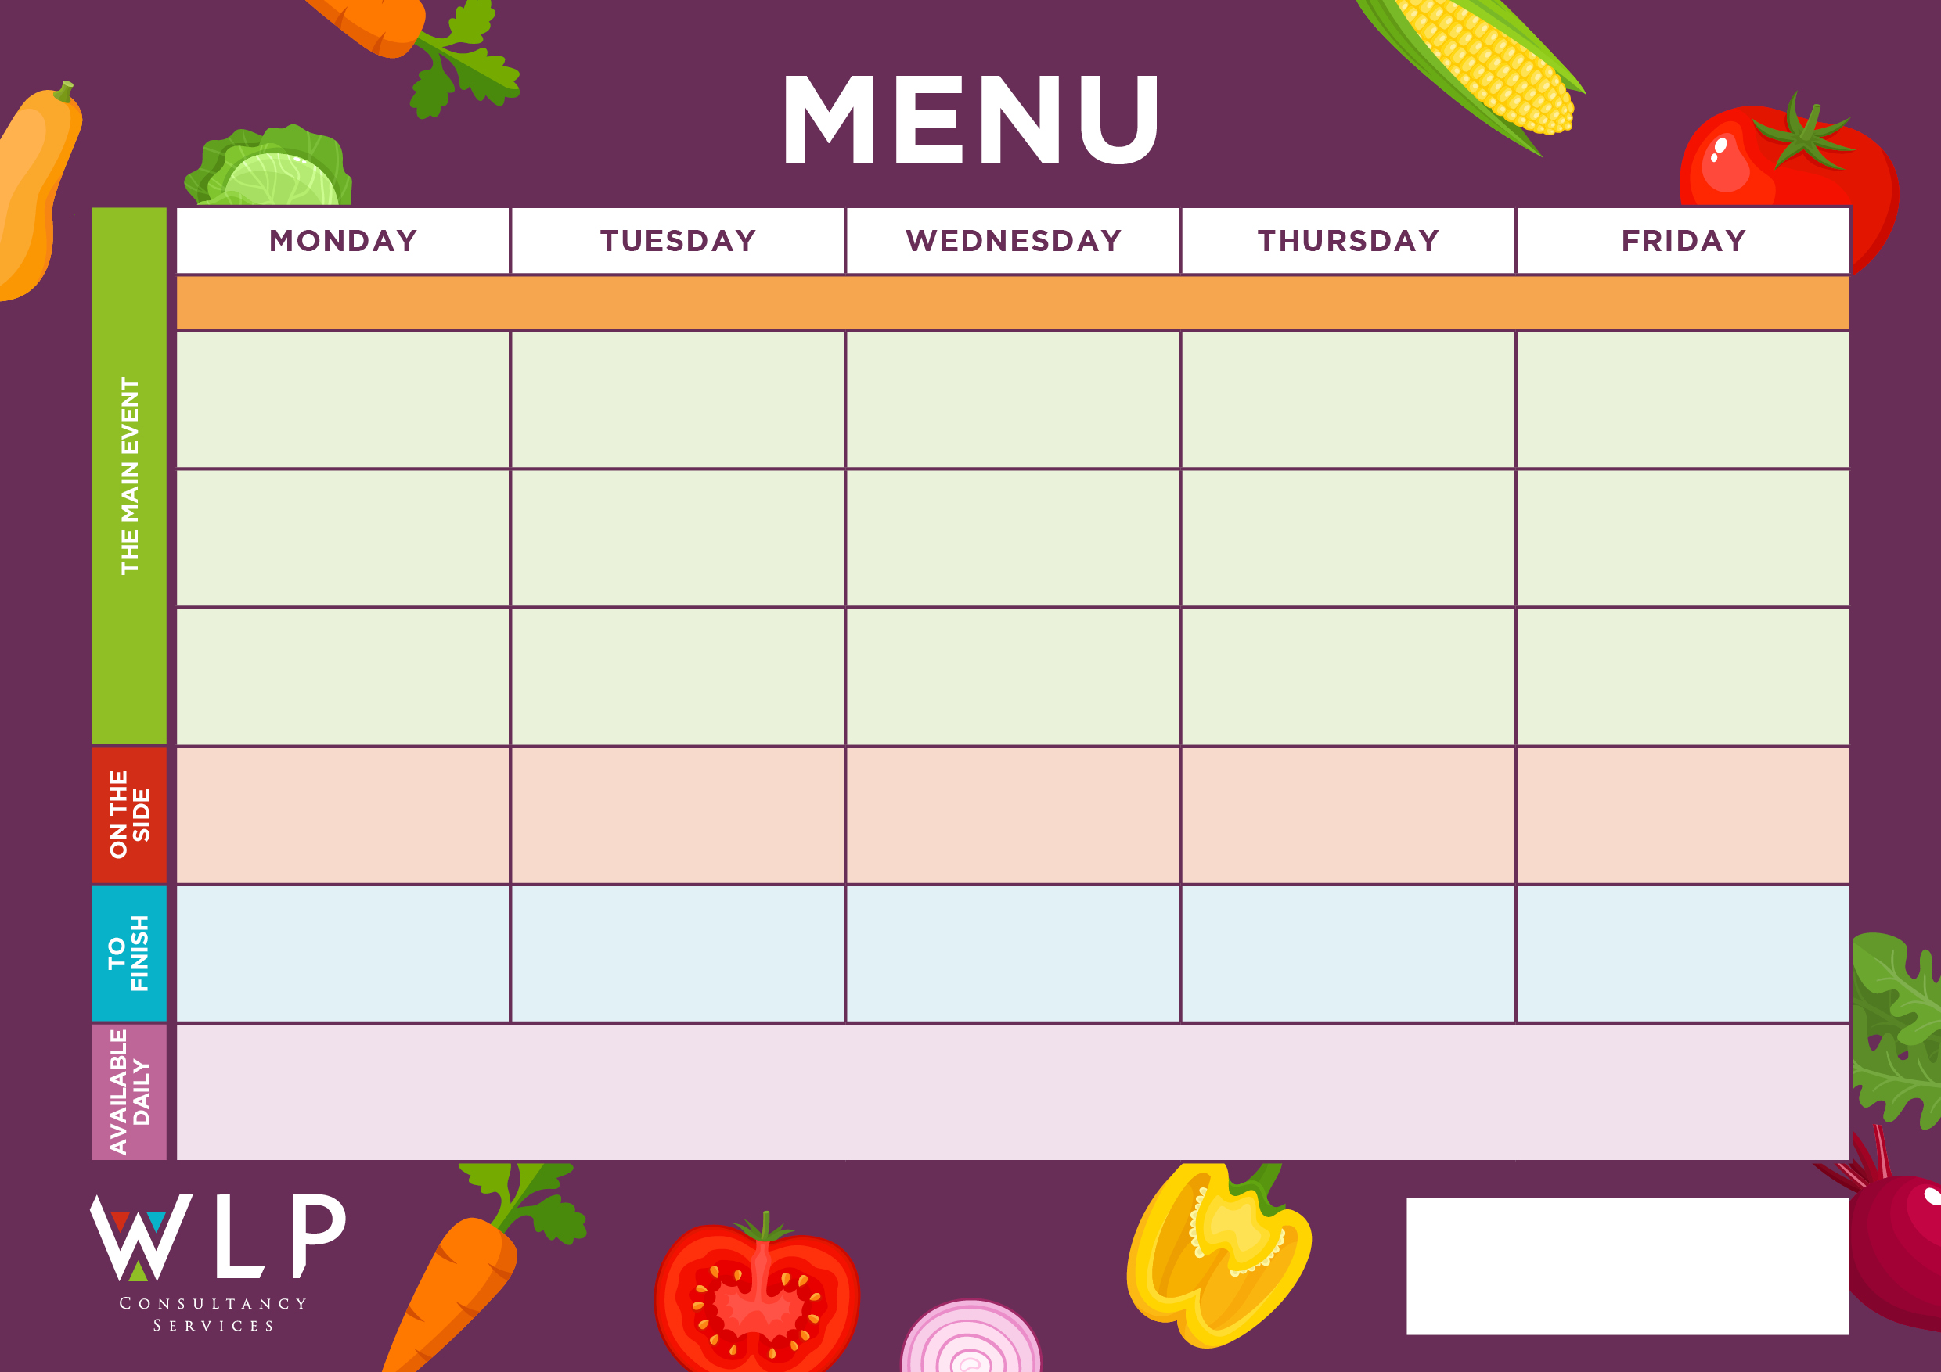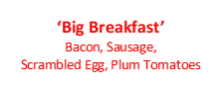



Fish Finger Wrap

***‘Pizza Bar’***

Roasted Vegetable or

Cheese & Tomato. Vegan option available.

‘**Big Veggie Breakfast’**

with Mushrooms. Vegan option available

Quorn fillet, Herby Stuffing & Gravy. Vegan option available

Jacket Potato with a selection of toppings.

Jacket Potato with selection of toppings

Cheesy pasta with Garlic Bread or Salmon Fishcake

Chunky Chips

Penne Pasta

Baked Beans, Peas

Roast & Creamed Potatoes

Carrots

Broccoli

Chocolate Sponge

Yoghurt

Coconut & Orange Cookie

Fruit

Jacket Potatoes with a selection of toppings

Vegan Sausage Roll

Beef Lasagne or Sausage Roll

Chunky Chips

Penne Pasta

Baked Beans, Sweetcorn

Roast & Creamed Potatoes

Carrots

Cabbage

Grab bags, freshly made bread, selection of salads.

Fresh fruit, assorted yoghurts, are readily available as an alternative to dessert of the day.

Additional vegetarian & vegan options are available upon request. Vegan desserts available.

**‘Big Breakfast’**

Bacon, Sausage,

Scrambled Egg, Plum Tomatoes

Roast Chicken with Herby Stuffing & Gravy

Vegan Roast Vegetable Pasta Bake

Sweet & Sour

Pork Balls

Oat Cookie

Fruit Platter

Vegan Pasta with Crusty Bread

Quorn Lasagne with Garlic Bread

Cottage Pie

Toffee Mousse with Mini Shortbread

Vegan/Vegetarian Sausage

Vegetarian Gravy

Potato Wedges

Green Beans

Mixed Vegetables

Ice Cream or

Cookie

Hash Browns

Sweetcorn

Baked Beans

**‘Big Breakfast’**

Bacon, Sausage,

Scrambled Egg, Plum Tomatoes

Selection of Oven Baked Crispy Fish

**Myddle CE Primary School Menu Week 2– 13th Nov, 27th Nov, 11th Dec, 4th Jan, 15th Jan, 29th Jan 2024**

Lemon Shortbread

Vegan Meatballs

Jacket Potato with a selection of toppings

Jacket Potato with a selection of toppings.

Oven Baked Crispy Fish Fingers

‘**Big Veggie Breakfast’**

with Mushrooms

Vegan/Vegetarian Fishless Fish-fingers

Vegetable Bake Burger

Roast Beef, Yorkshire Pudding & Gravy

Pork & Carrot Meatballs

Coconut & Orange Cookie

***‘Pizza Bar’***

Ham & Mushroom Or

Cheese & Tomato

Chocolate Chip Cookies

Fruit

Jacket Potato with a Selection of Toppings, Grab bags, Freshly made bread, selection of salads. Fresh fruit, assorted yoghurts,

are readily available as an alternative to dessert of the day.

Additional vegetarian & vegan options are available upon request. Vegan desserts available.

Potato Slices

Sweetcorn