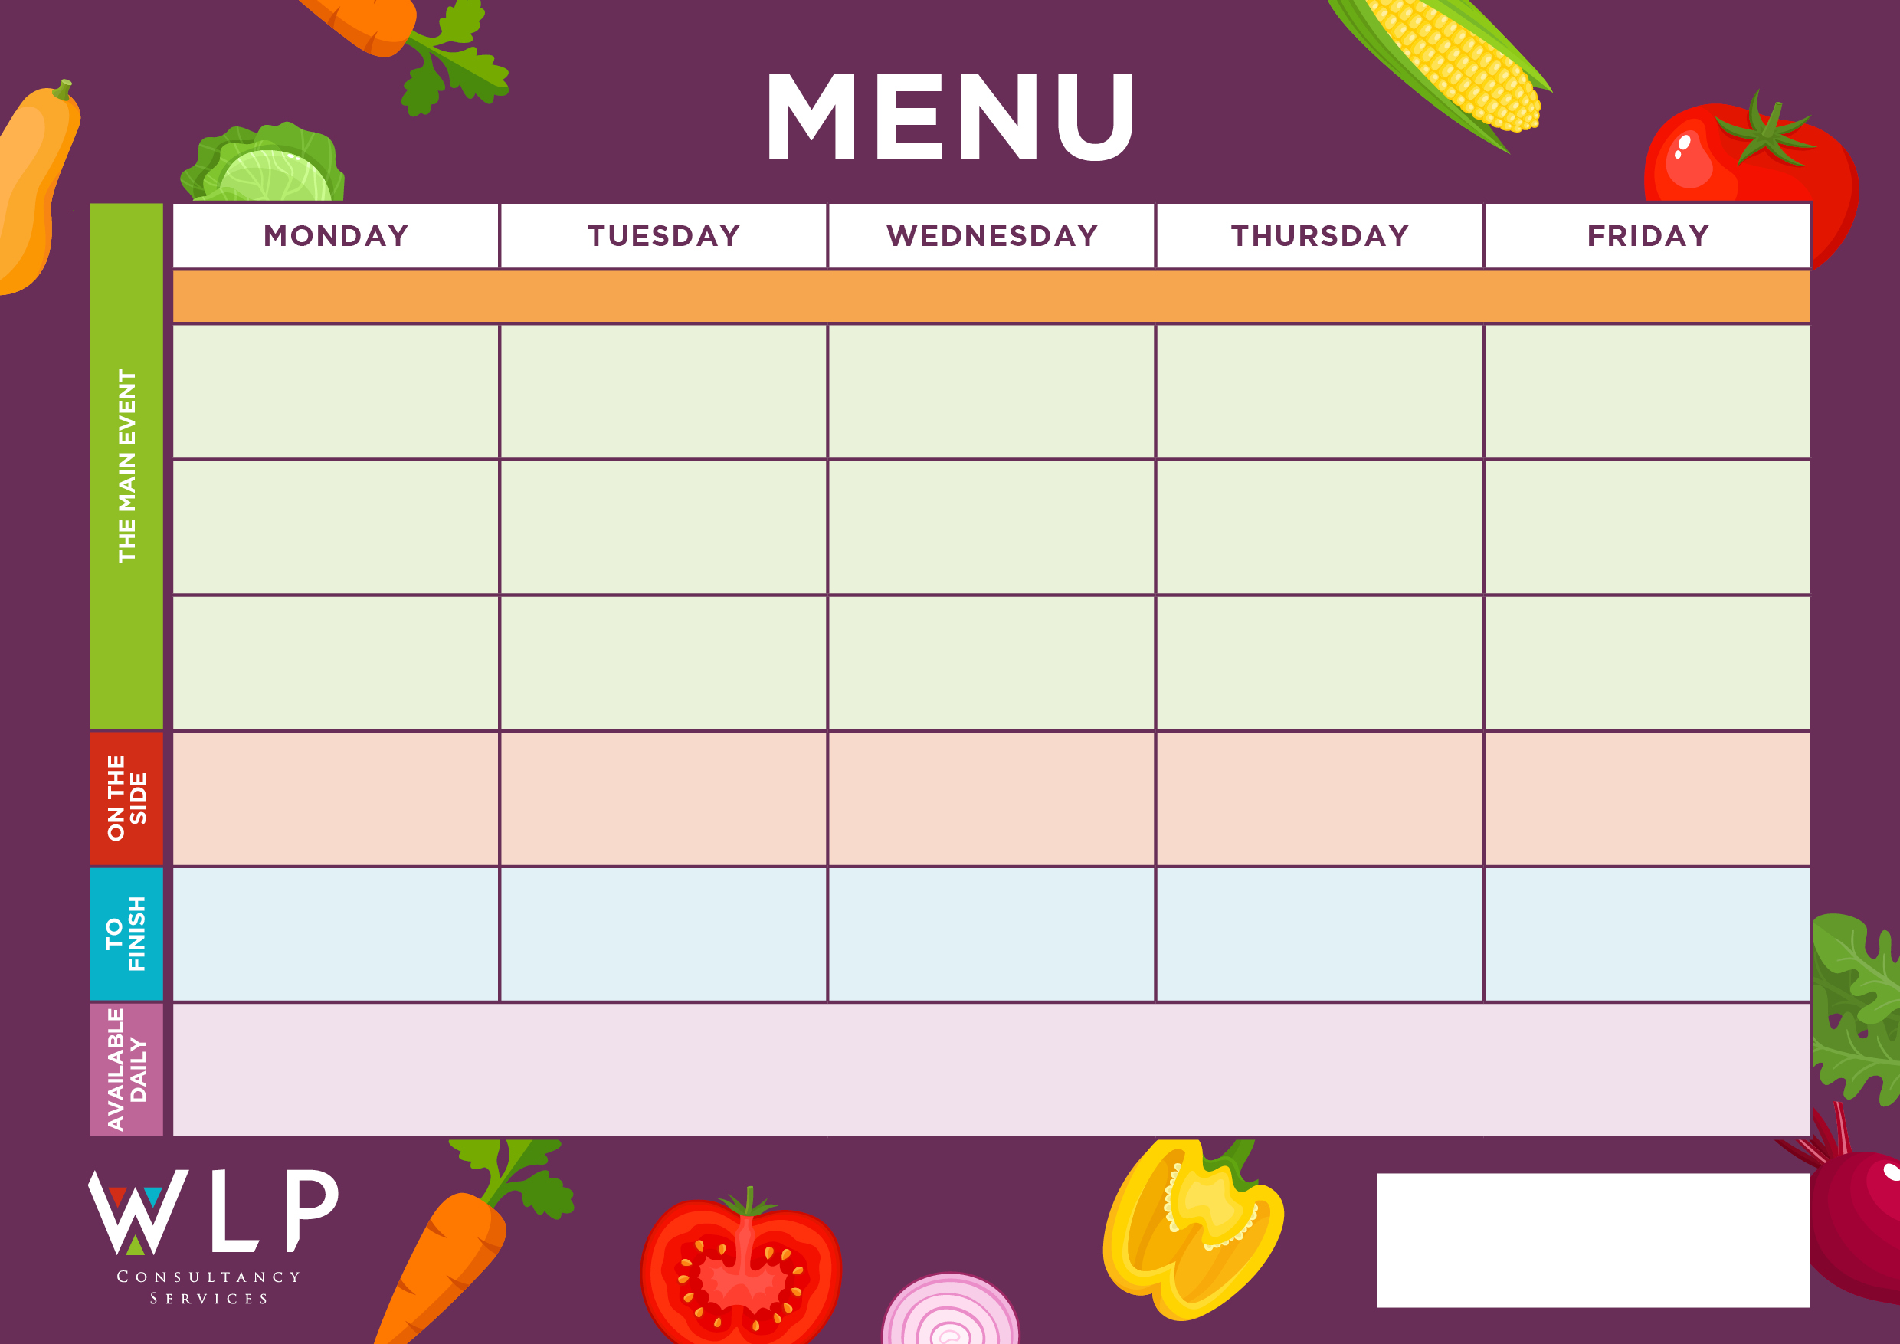



Oven Baked Crispy Fish Fillet

Chunky Chips

Penne Pasta

Baked Beans, Sweetcorn

Roast & Creamed Potatoes

Carrots

Peas

Toffee Mousse with Mini Shortbread

Oat Cookie

Fruit Platter

Vegan Pasta with Crusty Bread

Quorn Lasagne

Pasta Bolognaise

Chunky Chips

Penne Pasta

Baked Beans, Sweetcorn

Roast & Creamed Potatoes

Carrots

Cabbage

Jacket Potato with a Selection of Toppings, Grab bags, Freshly made bread, selection of salads.

Fresh fruit, assorted yoghurts, are readily available as an alternative to dessert of the day.

Additional vegetarian & vegan options are available upon request. Vegan desserts available.

Salmon Fishcake

***‘Pizza Bar’***

Pepperoni Or

Cheese & Tomato

‘**Big Veggie Breakfast’**

with Mushrooms

**‘Big Breakfast’**

Bacon, Sausage,

Scrambled Egg, Plum Tomatoes

Vegan/Vegetarian Quorn Fillet

Roast Chicken, Herby Stuffing & Gravy

Fishless Fingers

Sweet & Sour

Pork Balls

Oat Cookie

Fruit Platter

Vegan Pasta with Crusty Bread

Quorn Lasagne with Garlic Bread

Cottage Pie

Toffee Mousse with Mini Shortbread

Vegan/Vegetarian Sausage

Vegetarian Gravy

Potato Wedges

Peas

Baked Beans

Frozen Yoghurt or

Fruit

Hash Browns

Plum Tomatoes

Baked Beans

**‘Big Breakfast’**

Bacon, Sausage,

Scrambled Egg, Plum Tomatoes

Selection of Oven Baked Crispy Fish

**Myddle CE Primary School Menu Week 2 – 24th April, 15th May, 12th June, 3rd July, 11th Sept, 2nd & 23rd Oct 2023**

Lemon Shortbread

Vegan Meatballs

Vegan Big Breakfast with Mushrooms

Vegan Pizza

Oven Baked Crispy Fish Fingers

‘**Big Veggie Breakfast’**

with Mushrooms

Vegan/Vegetarian Fishless Fish-fingers

Vegetable Bake Burger

Roast Beef, Yorkshire Pudding & Gravy

Pork & Carrot Meatballs

Coconut & Orange Cookie

***‘Pizza Bar’***

Ham & Mushroom Or

Cheese & Tomato

Selection of Cookies

Jacket Potato with a Selection of Toppings, Grab bags, Freshly made bread, selection of salads. Fresh fruit, assorted yoghurts,

are readily available as an alternative to dessert of the day.

Additional vegetarian & vegan options are available upon request. Vegan desserts available.

Mixed Vegetables

Sweetcorn