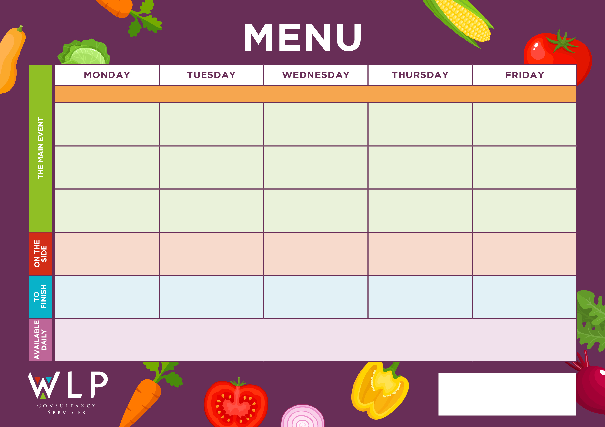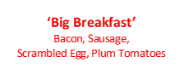



Rice

Pasta

Mixed Vegetables

Sweetcorn

Roast & Creamed Potatoes

Carrots

Broccoli

Roast Chicken, Herby Stuffing & Gravy

Vegetarian/Vegan Sausage with Onion Gravy

Vegan Cheesy Pasta with Crusty Bread

Quorn Fillet with Herby Stuffing & Gravy

Sausage with Onion Gravy

Chunky Chips

Penne Pasta

Baked Beans

Shortbread or Yoghurt

Chocolate Sponge

Vegan Burger in a Bap

Chicken Tender Fillets or Beef Burger in a Bap

Chunky Chips

Penne Pasta

Baked Beans, Sweetcorn

Roast & Creamed Potatoes

Carrots

Cabbage

Jacket Potato with a Selection of Toppings, Grab bags, Freshly made bread, selection of salads.

Fresh fruit and assorted yoghurts, are readily available as an alternative to dessert of the day.

Additional vegetarian & vegan options are available upon request. Vegan desserts available.

Vegetable Burger Bake

***‘Pizza Bar’***

Ham & Pineapple Or

Cheese & Tomato

Fishless Fingers

Oven Baked Fish Fillet

Sweet & Sour

Pork Balls

Oat Cookie

Fruit Platter

Vegan Pasta with Crusty Bread

Quorn Lasagne with Garlic Bread

Cottage Pie

Toffee Mousse with Mini Shortbread

Vegan/Vegetarian Sausage

Vegetarian Gravy

Mashed Potatoes

Carrots

Peas

Ginger Sponge

**‘Big Breakfast’**

Bacon, Sausage,

Scrambled Egg, Plum Tomatoes

Selection of Oven Baked Crispy Fish

**Myddle CE Primary School Menu Week 3 – 1st & 22nd May, 19th June, 10th July, 18th Sept, 9th Oct 2023**

Ice Cream or

Fruit

Vegan Meatballs

Vegan Pizza

Oven Baked Crispy Fish Fingers

‘**Big Veggie Breakfast’**

with Mushrooms

Vegan/Vegetarian Fishless Fish-fingers

Vegetable Bake Burger

Roast Beef, Yorkshire Pudding & Gravy

Pork & Carrot Meatballs

Coconut & Orange Cookie

***‘Pizza Bar’***

Ham & Mushroom Or

Cheese & Tomato

Chocolate Chip Cookie

Fruit Platter

Jacket Potato with a Selection of Toppings, Grab bags, Freshly made bread, selection of salads. Fresh fruit, assorted yoghurts,

are readily available as an alternative to dessert of the day.

Additional vegetarian & vegan options are available upon request. Vegan desserts available.

Herby Diced Potatoes

Baked Beans

Sweetcorn