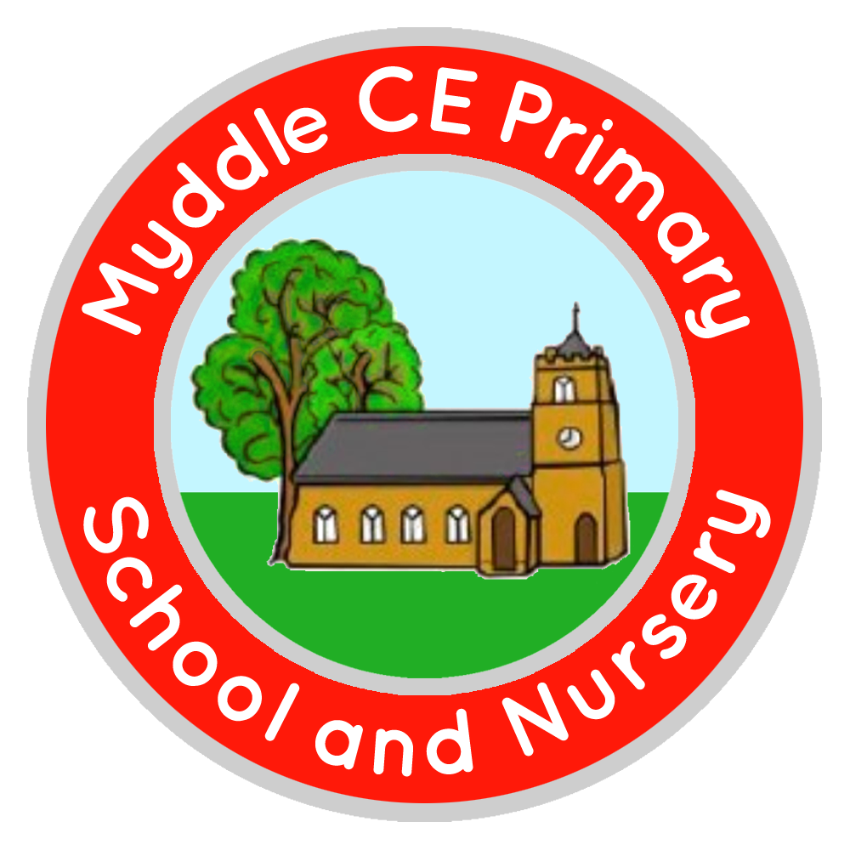
Myddle C.E Primary School and Nursery
Myddle
SHREWSBURY, SY4 3RP

Telephone: 01939 290834
e-mail: admin@myddle.shropshire.sch.uk
www.myddleschool.org.uk

Executive Headteacher Mrs C Williams

‘Growing, learning and living in the love of God’



Dear Parents/Carers

PANTOMIME 2022

It’s that time of year again (oh yes it is!) where we would like to take the children to experience the pantomime, Beauty and The Beast, at Theatre Severn in Shrewsbury.

This event is for children in Panda, Tiger, Rhino and Jaguar class and will take place on the afternoon of Tuesday , 6th December. We will travel by bus and will return to school at approximately 5pm. The PTA have kindly covered the cost of the transport.

Due to legal Ratio requirements for Educational Visits, we are unable to include pupils of Snowleopards but please don’t worry as snowleopards will be taking part in lots of fun Christmas activities during the day.

The cost of this trip is £11.80 per child.

Payments should be made online via the Schoolgateway by 3rd November 2022. If you need help regarding this, please contact the school office.

Yours sincerely

Mrs C Williams
Headteacher
-------------------------------------------------------------------------------------------------------

Pantomime 2022 – 6th December 2022

Name of child…………………………………………………………………………………………… Class……………………………

I give permission for my child to attend the Pantomime at Theatre Severn on Tuesday, 6th December and have made payment via School Gateway.

Signed…………………………………………………………………..Parent/Carer

