Myddle CE Primary School
Science Action Plan
2022-2023
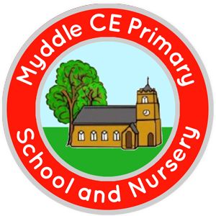

Science
Action | Success Criteria | Resources | Timescale | Monitoring & Evaluation
Intent
- Having oversight of curriculum coverage
- Colleague expectations
- Action plan for future development
- Ensuring resources are in place for a rich and challenging curriculum
*To ensure the sequence of Science topics show progression in learning objectives as the pupils continue throughout the school. | *All teachers to be teaching the Science topics appropriate to their year groups to ensure progression, using the PLAN progression of objectives | *PLAN year group objectives | *Throughout the year | Book monitoring in Summer half term 2 to evaluate
*To teach Science units appropriate to the year groups in each class and update display boards in classrooms for each new Science topic taught | *All teachers / TAs to update display boards in their classrooms, including reference to scientific enquiry in lessons | *Display boards  *Twinkl display resources  *Photographs of pupils working investigately | *Each half term, take a photograph of evidence of display boards and share with parents on the school website | Monitor throughout the year
Implementation
- Ensure that teaching of Science is strong and promotes the acquisition of key knowledge
- Leading professional development, providing guidance and support
- Oversee assessment
- Promoting the subject throughout the school to staff, pupils and parents
*To use ‘Grammarsaurus’ as a formal way of assessing pupils at the end of each topic to identify if pupils are working ‘at’ or ‘working towards’ the expected standard | *All teachers to use ‘Grammarsaurus’ end of topic assessment as a formal way of pupils knowledge and understanding | *Grammarsaurus | *End of each half term | *Book monitoring during Summer half term 2  *Collect in key skills assessments at end of each half term
*To promote the Science subject to parents and offer opportunities for feedback to aid development | *Parents to understanding how Science is taught within school and to have had opportunity to respond | *School website  *Facebook  *Class dojo | *Autumn term | *Receive any feedback by end of Autumn term to evaluate for future progression
Impact
- Monitoring the effectiveness of teaching and the impact on learning and standards
- Evaluating and summarising all aspects of the subject to define next steps for improvement
*To observe a science lesson from each teacher to identify the impact on learning | *All teachers to have been observed teaching Science to a year group, with a lesson focus on ‘scientific enquiry’ |  | *By end of Spring Term 2 | *By end of year, each teacher to have been observed in teaching of Science using scientific enquiry

