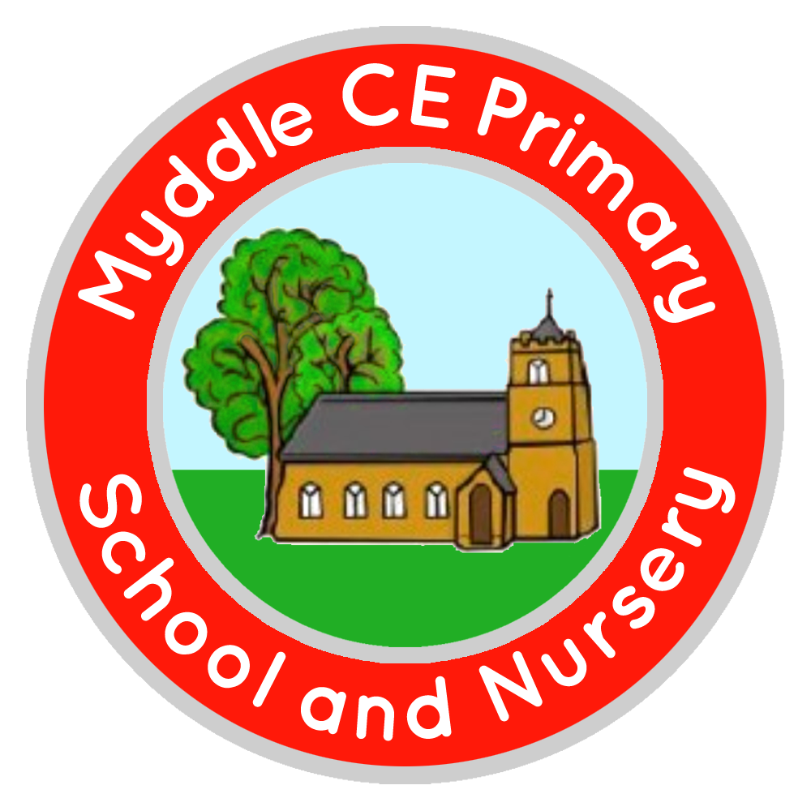
Myddle C.E Primary School and Nursery
Myddle
SHREWSBURY, SY4 3RP

Telephone: 01939 290834
e-mail: admin@myddle.shropshire.sch.uk
www.myddleschool.org.uk

Executive Headteacher Mrs C Williams

‘Growing, learning and living in the love of God’



20th May 2022

Dear Parents/Carers

Y6: Crucial Crew

Every year our Y6 pupils are invited to take part in ‘Crucial Crew’ which is a safety day run by West Mercia Police. This event takes place on Friday 10th June.

The cost of this event is £4.00, this goes towards the cost of the day and transport. Payments can be made via School Gateway.

Children will be accompanied by Mrs Harris and should be in school uniform but may wear trainers. Please ensure your child has a packed lunch with spare drinks in a backpack, they may also bring a snack to have mid-morning. FSM children will have a packed lunch provided by school but should bring a back pack to carry it in. If you would like your child to have a grab and go bag, this will cost £2.30 (normal dinner cost). Please indicate their sandwich choice on the return slip.

Please also ensure your child has a waterproof coat/sun hat depending on the weather.

Please return your child’s permission slip by Monday 6th June.

Yours sincerely
C Williams
Mrs C Williams
Executive Headteacher
----------------------------------------------------------------------

Crucial Crew: Y6 Friday 10th June

I give permission for my child _______________________________to take part in Crucial Crew

I have paid £4.00 via School Gateway for this event.

Grab Bag: White Roll □ Brown Roll □ Wrap □ Baguette □
Filings Choice: Cheese □ Ham □ Tuna Mayo □ Egg Mayo □

Signed _____________________________________ parent/carer

