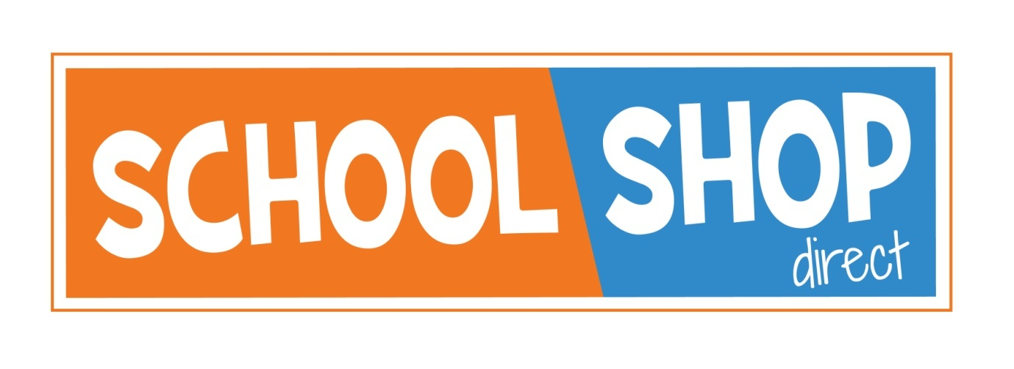

EARLIER ORDER DISCOUNT

We are offering a 7% discount off the standard price for all Corbet School uniform.

In store – the discount will be automatically applied at the till
On line – the discount will be applied at the online checkout – Please use order code EARLYORDER22

This discount applies from June 20th to July 23rd 2022

17-18 Sundorne Trade Park, Featherbed Lane, Shrewsbury, SY1 4NS
Telephone 01743 440449 e-mail info@schoolshopdirect.co.uk
www.schoolshopdirect.co.uk

