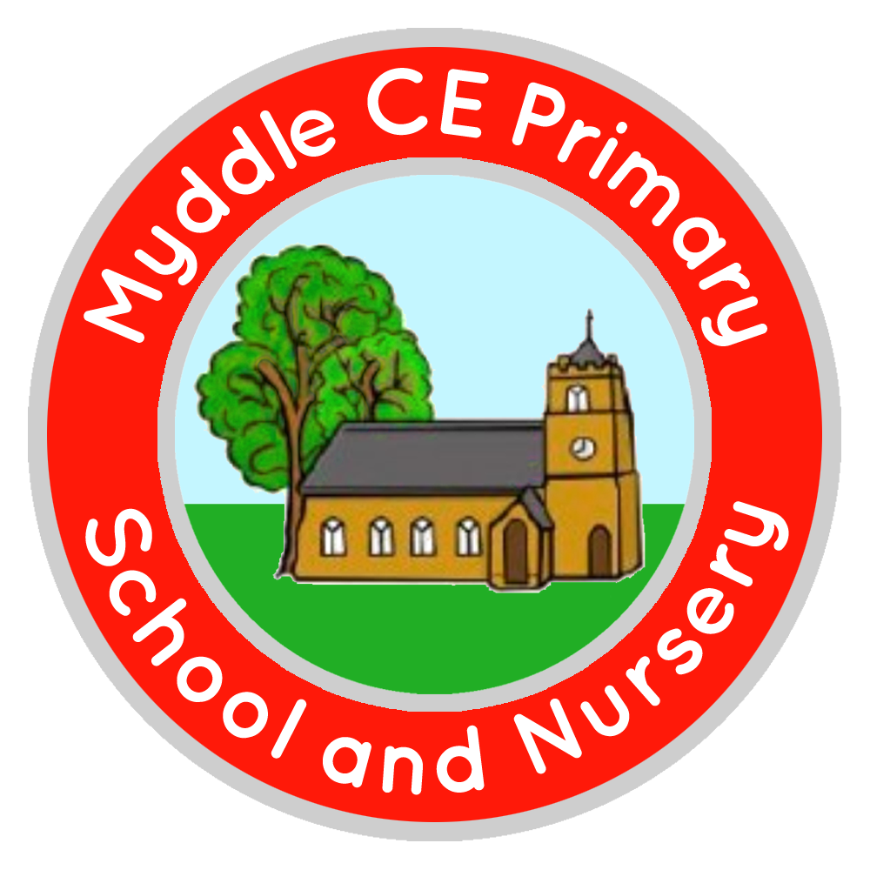
Myddle C.E Primary School and Nursery
Myddle
SHREWSBURY, SY4 3RP

Telephone: 01939 290834
e-mail: admin@myddle.shropshire.sch.uk
www.myddleschool.org.uk

Executive Headteacher Mrs C Williams

‘Growing, learning and living in the love of God’



16th May 2022
Thursday 26th May
Platinum Jubilee Celebrations
To celebrate the Queens Platinum Jubilee we are planning several fun activities that all of the children will be able to take part in.

We will be “Dressing to Impress” and asking that the children come to school dressed in their best wedding/party outfits. As this event is the same day as swimming for Rhino and Jaguar Class, please can they arrive in their uniform as normal for swimming and bring their special outfit in a separate bag.

At lunchtime we will be holding a Queens Jubilee picnic (weather permitting) on the school field. During the afternoon sessions, they will be having fun taking part in games and activities relating to The Queen in each class.

School Dinners on this day, will only be “grab and go” bags available or you can send in a packed Lunch from home. Please can you tick your child’s preference for lunch on the return slip and return to school by Thursday 19th May.

If you have any questions, please do not hesitate to contact Mrs Smith.

Yours sincerely,

Mr Glover
Assistant Head teacher

---------------------------------------------------------------------------------------------------------------------------------- Jubilee Picnic Choices – Thursday 26th May
Child Name: Class …………………………………………

Tick one box - White Roll □ Brown Roll □ Wrap □ Baguette □

Tick one box - Cheese □ Ham □ Tuna Mayo □ Egg May □

Own Packed lunch □

Parents Signature ……………………………………………

