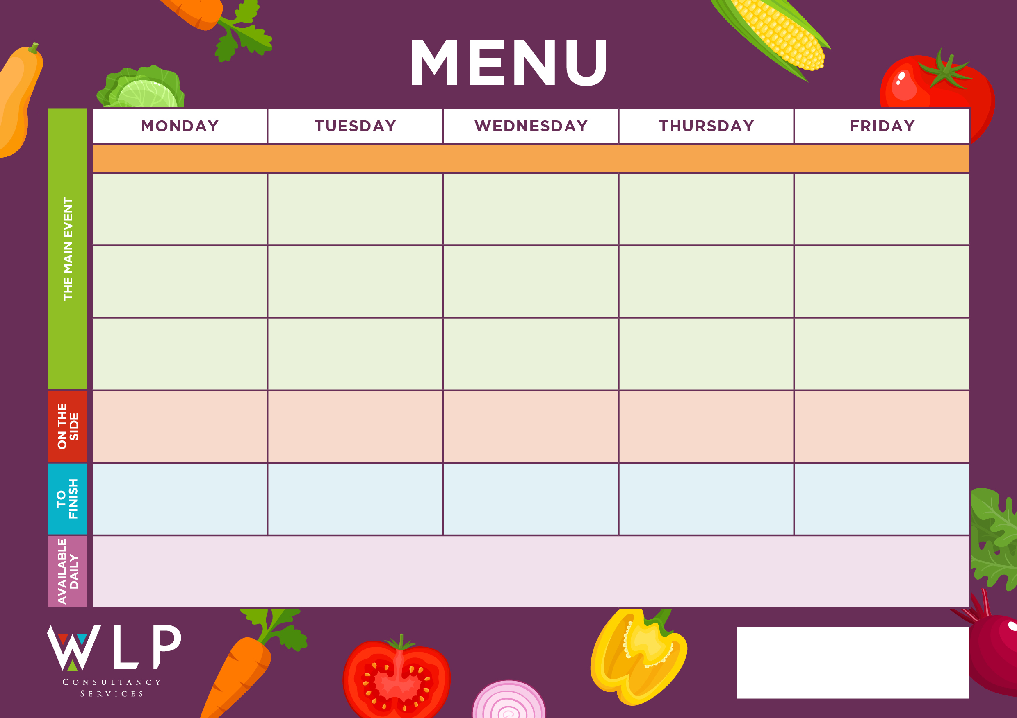

Vegan Burger

Potato Wedges

Sweetcorn

Baked Beans

Vegan Pizza

Quorn Fillet with Herby Stuffing & Gravy

Oven Baked Crispy Fish Fillet

Freshly Baked Sausage Roll

Vegan Pizza

Vegan Burger

Chunky Chips

Penne Pasta

Baked Beans

Lemon Shortbread

Pasta Neapolitan with Crusty Bread

Jelly or Yoghurt

Jacket Wedges

Sweetcorn

Baked Beans

Saute Potatoes

Peas

Sweetcorn

Beefburger or Turkey Burger

**Baschurch CE Primary School Menu Week 3 – W/C 9th May, 6th June, 27th June, 18th July, 19th Sept, 10th Oct**

Ginger Sponge

Quorn Nuggets

Vegan Quorn

Vegan Cheesy Pasta with Crusty Bread

Sausage Roll

Cheesy Pasta with Garlic bread

Cheese & Red Onion Quiche

Vegetable Burger

Traditional Roast Chicken with Herby Stuffing & Gravy

Chicken Tender Fillets

Chocolate Sponge

***‘Pizza Bar’***

Ham & Pineapple or

Cheese & Tomato

Roast & Creamed Potatoes

Carrots

Broccoli

Chocolate Chip Cookie

Fruit Platter.

Freshly made bread, selection of salads, fresh fruit, assorted yoghurts,

are readily available as an alternative to dessert of the day.

Additional vegetarian & vegan options are available upon request. Vegan desserts available.

Herby Diced Potatoes

Baked Beans

Peas