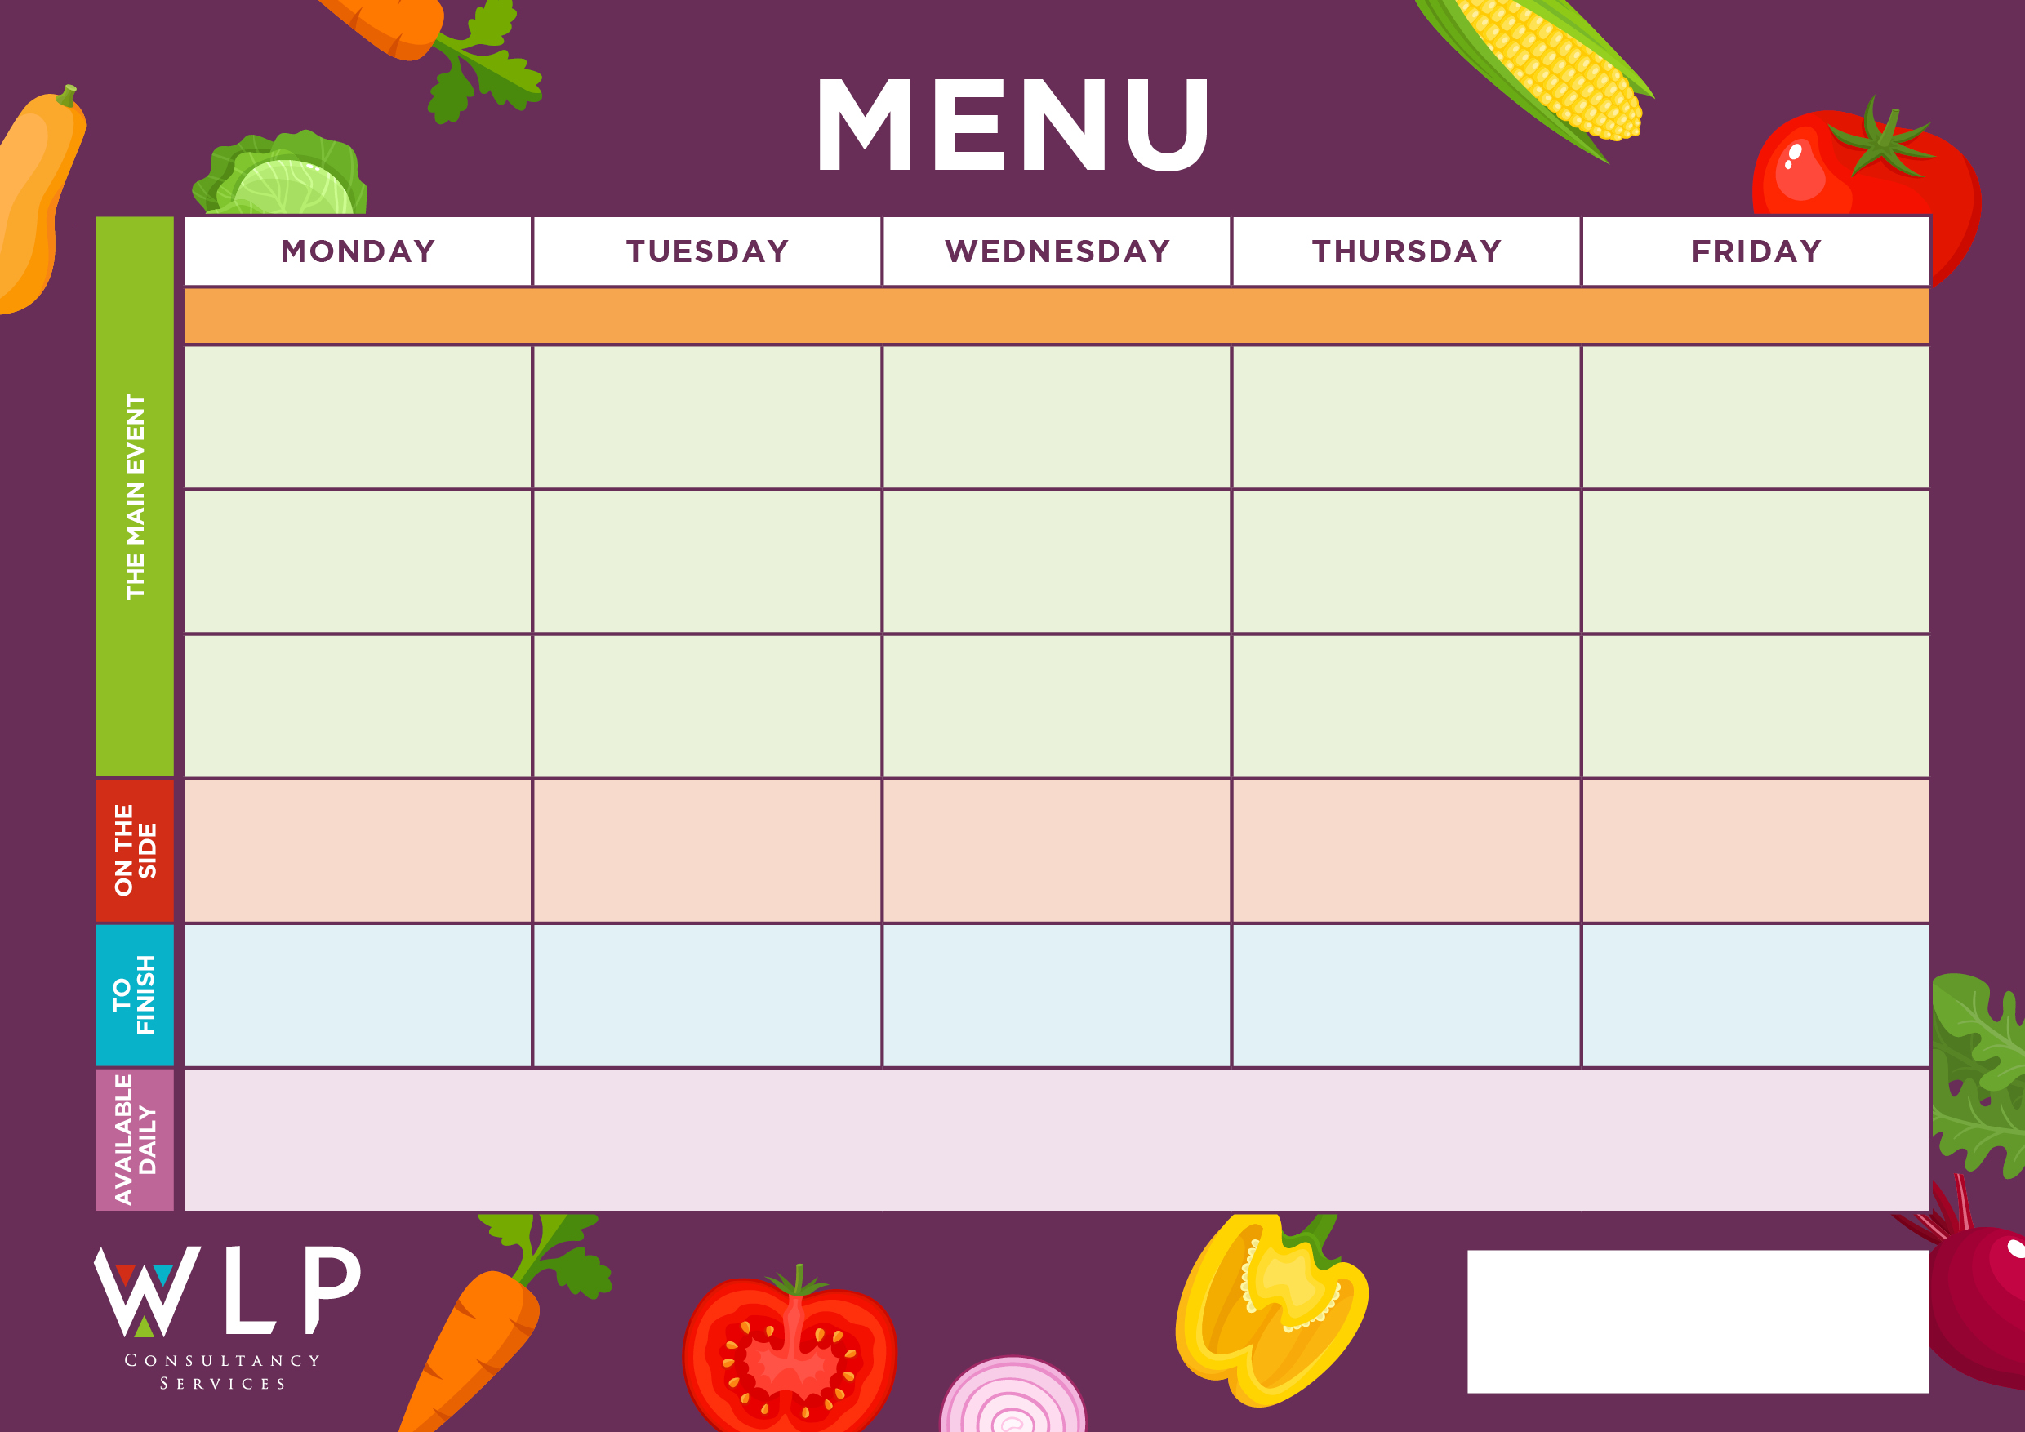

Vegan Pizza

Vegan Pasta with Crusty Bread

Chunky Chips

Penne Pasta

Baked Beans

Sweetcorn

Flapjack

Vegetarian Sausage with Yorkshire Pudding & Gravy

Toffee Mousse with Mini Shortbread

Pasta

Potato Wedges

Assorted Salad

Hash Brown Potatoes

Plum tomatoes or

Baked Beans

‘Big Breakfast’

(Bacon, Sausage, Scrambled Egg)

Chicken Fajitas

**Baschurch CE Primary School Menu Week 2 – W/C 2nd May, 23rd May,23rd May, 20th June, 11th July, 12th Sept, 3rd Oct**

Frozen Yoghurt

Vegan Nuggets

Vegan Cumberland Sausage & Tasty Gravy

‘Vegan Big Breakfast’

with Mushrooms

Salmon Fishcake

‘Veggie Big Breakfast’

with Mushrooms

Quorn Fajitas

Quorn Lasagne with Garlic Bread

Traditional Roast Beef with Yorkshire Pudding & Gravy

Ham Carbonara with Garlic Bread

Oat Cookie

Fruit Platter

***‘Pizza Bar’***

Pepperoni or

Cheese & Tomato

Roast & Creamed Potatoes

Carrots

Cabbage

Selection of Cookies

Freshly made bread, selection of salads, fresh fruit, assorted yoghurts,

are readily available as an alternative to dessert of the day.

Additional vegetarian & vegan options are available upon request. Vegan desserts available.

Mixed Vegetables

Sweetcorn