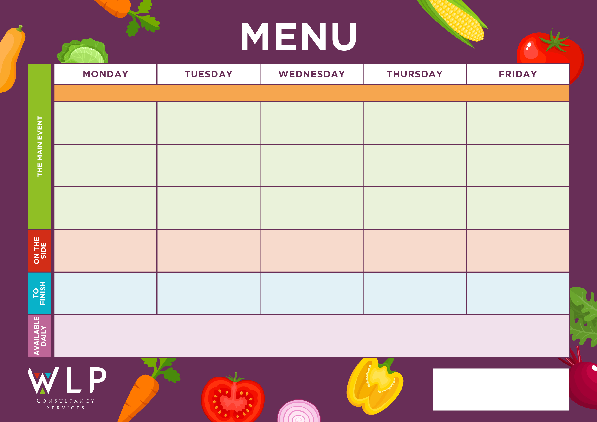

Vegan Crumb Schnitzel

Flapjack or Ice Cream

Hash Browns

Sweetcorn

Baked Beans

**‘Big Breakfast’**

Bacon, Sausage,

Scrambled Egg, Plum Tomatoes

Selection of Oven Baked Crispy Fish

**Baschurch CE Primary School Menu Week 1 –25th April, 16th May, 13th June, 4th July, 5th Sept, 26th Sept, 17th Oct**

Jelly or Cookie

Iced Vanilla Sponge

Vegan Meatballs

Vegan Curry & Naan Bread

Vegan Big Breakfast with Mushrooms

Vegan Pizza

Oven Baked Crispy Fish Fingers

‘**Big Veggie Breakfast’**

with Mushrooms

Quorn Fillet, Herby Stuffing & Vegetarian Gravy

Vegetable Curry & Naan Bread

Vegetable Bake Burger

Traditional Roast Chicken, Herby Stuffing & Gravy

Pork & Carrot Meatballs

Coconut & Orange Cookie

***‘Pizza Bar’***

Ham & Mushroom Or

Cheese & Tomato

Roast & Creamed Potatoes

Carrots

Broccoli

Chunky Chips

Penne Pasta

Baked Beans, Peas

Assorted Muffins

Shortbread

Jacket Potato with a Selection of Toppings, Grab bags, Freshly made bread, selection of salads. Fresh fruit, assorted yoghurts,

are readily available as an alternative to dessert of the day.

Additional vegetarian & vegan options are available upon request. Vegan desserts available.

Jacket Wedges

Seasonal Vegetables

Jacket Wedges.

Pasta

Carrots, Baked Beans