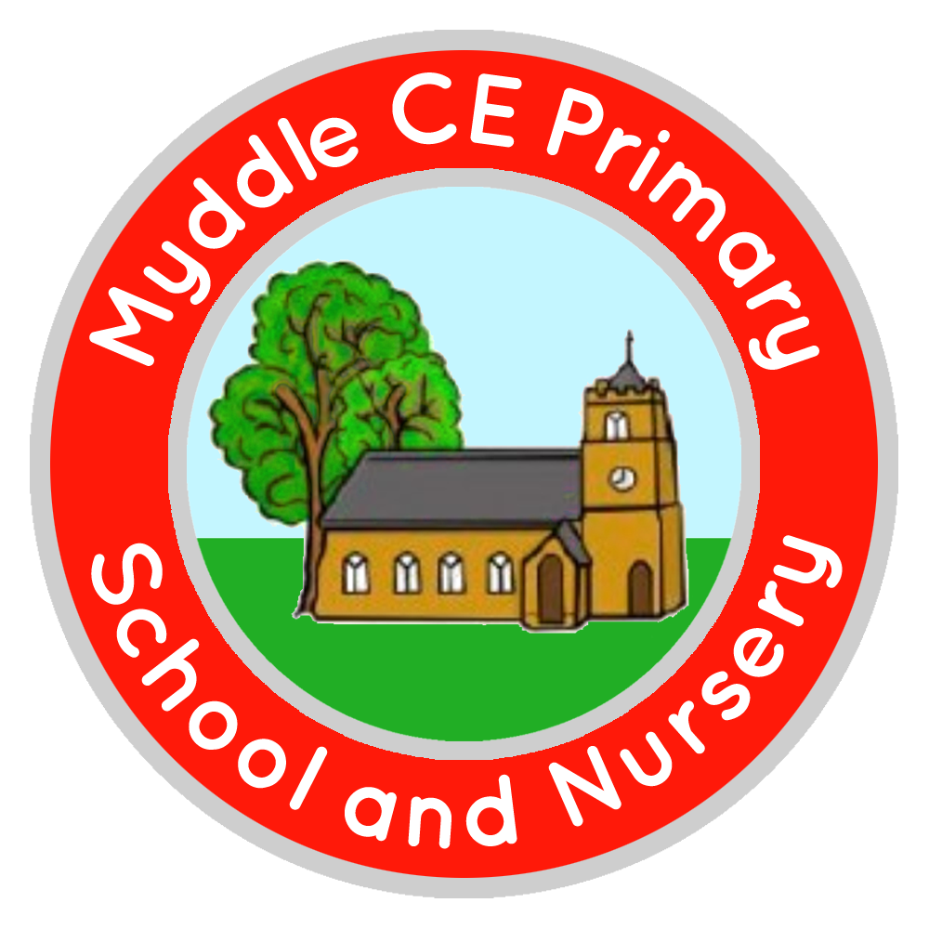
Myddle C.E Primary School and Nursery
Myddle
SHREWSBURY, SY4 3RP

Telephone: 01939 290834
e-mail: admin@myddle.shropshire.sch.uk
www.myddleschool.org.uk

Executive Headteacher Mrs C Williams

‘Growing, learning and living in the love of God’



Monday 7th February 2022

Dear Parents/Carers

Shropshire Primary Schools Half Marathon
(in association with the Shrewsbury Half Marathon)

The Shropshire Schools Half Marathon is a cumulative Half Marathon (13.1 miles) where
over the course of a term children complete the first 12 miles of the challenge. They then
complete their final 1.1 miles at the West Mid Showground in Shrewsbury on Saturday 09
April 2022. Here they will get the full race experience, including bibs, a fully marshalled
route, music and a start and finish line gantry. As they cross the finish line, they will be
presented with their medal and finishers t-shirt.

The children’s race will not be timed and will not have prizes for the fastest children. It is
an inclusive challenge where over a period of time they are developing healthy habits to
exercise regularly.

How does it work?

The 12 miles are completed 1 mile at a time. We will have an achievement chart for all the
children, where they can log each mile they complete.

The cost of entry is £12 per child.

We would love to have as many children take part as possible, in an event which is
designed to promote inclusion, encourage regular physical activity, and develop
characteristics such as resilience, commitment, organisation, confidence and
determination.

Please visit the School Gateway to register your child and make the £12.00 payment.

Once you have registered online, please check that you have received email confirmation.

This must be done by Thursday 10 February to secure a place for your child, as we will
need to book them in advance. Entries will not be accepted after this date.

Yours Sincerely

Mr G Hughes
PE Co-ordinator

