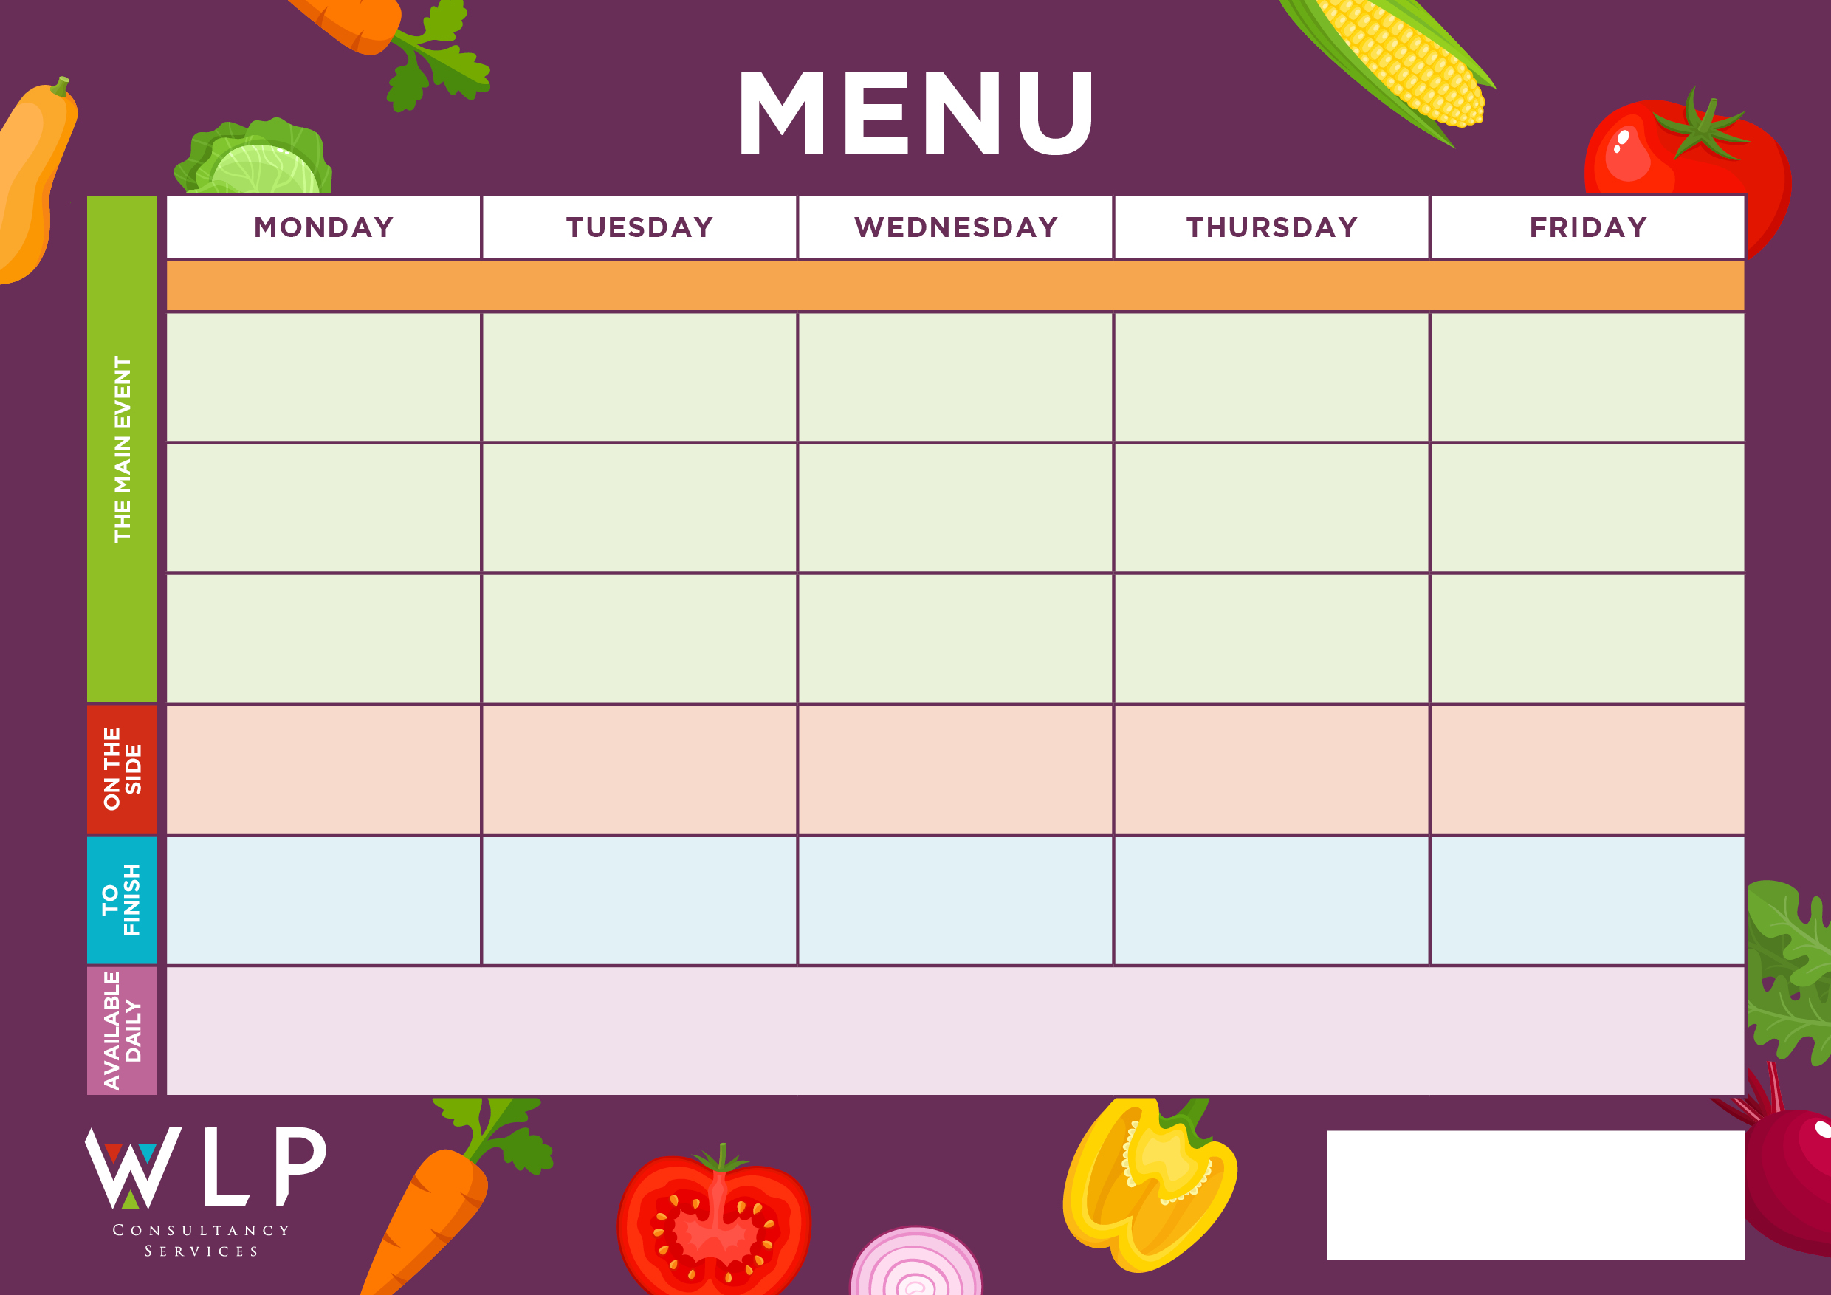

Vegan Big Breakfast with Mushrooms

Vegan Bolognaise

**‘Big Breakfast’**

Bacon, Sausage,

Scrambled Egg, Plum Tomatoes

Traditional Roast Chicken with Stuffing & Gravy

Chipped Potatoes

Pasta

Peas

Baked Beans

Pancakes with Fruit Slices

Quorn Fillet & Gravy

Fruit Jelly

Ice Cream

Garlic Bread Slice

Peas

Carrots

Hash Browns

Baked Beans

Spaghetti Bolognaise

**Myddle CE Primary School Menu Week 3 15th Nov, 6th Dec, 10th Jan, 31st Jan 2022.**

Apple Crumble & Custard

Crispy Baked Vegan Nuggets

Vegan Cowboy Pie

Vegan Pizza

Oven Baked Salmon Fishcake

‘**Big Veggie Breakfast’**

with Mushrooms

Quorn Lasagne

Macaroni Cheese with Garlic Bread

Chicken Breast Tenders

Ginger Sponge & Custard

***‘Pizza Bar’***

Ham & Mushroom Or

Cheese & Tomato

Roast & Creamed Potatoes

Carrots

Peas

Shortbread

Jacket Potato With Selection of Toppings, Grab bags, Freshly made bread, selection of salads. Fresh fruit, assorted yoghurts

are readily available as an alternative to dessert of the day.

Additional vegetarian & vegan options are available upon request. Vegan desserts available.

Potato Wedges

Green Beans

Sweetcorn