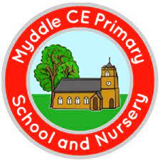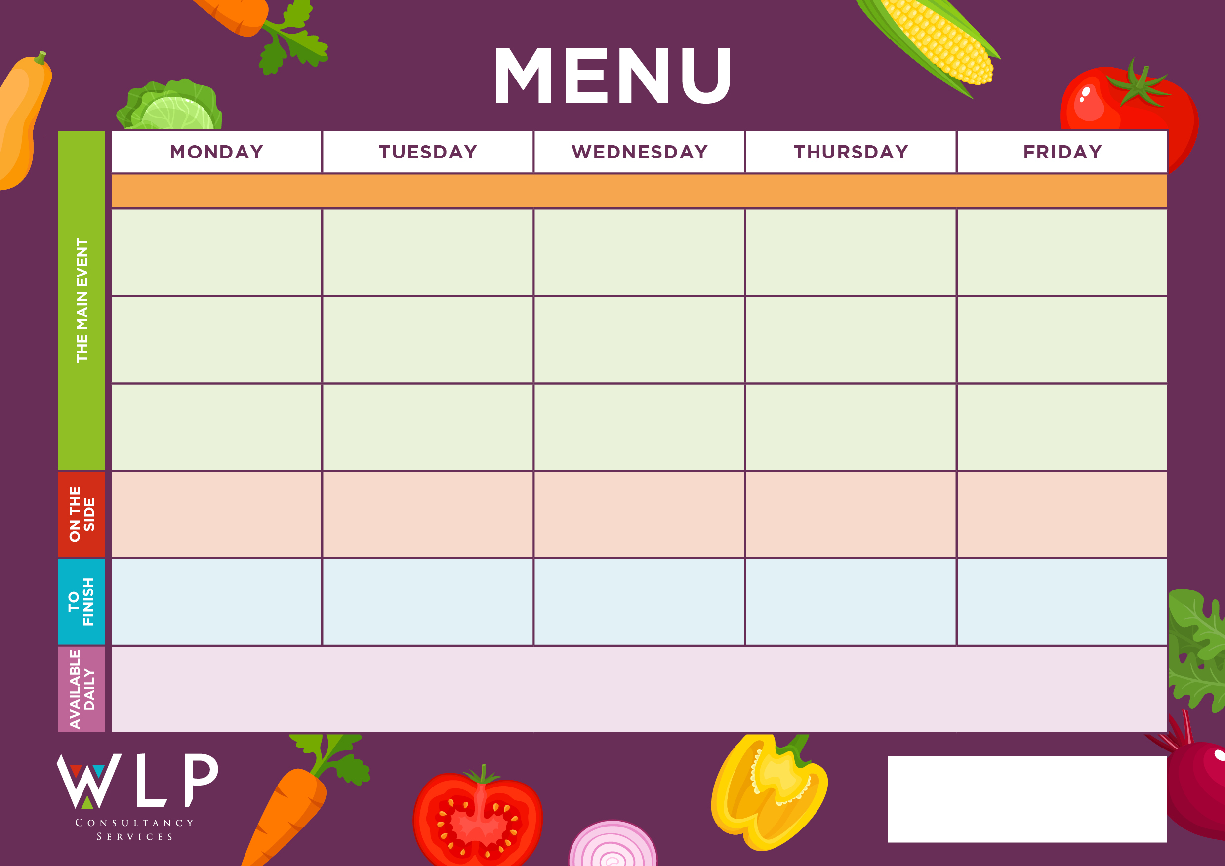

Vegan Pizza

Vegan Vegetable Curry

Chipped Potatoes

Pasta

Baked Beans

Sweetcorn

Selection of Cookies

Vegetarian Sausage with Yorkshire Pudding & Gravy

Fruit Swirl Sponge

Pasta

Seasonal Vegetables

Baked Beans

Baby Potatoes

Seasonal Vegetables

Baked Beans

Selection of Oven Baked Fish

Meatballs with Freshly Made Tomato Sauce

**Myddle CE Primary School Menu Week 2 – 8th Nov, 29th Nov, 4th Jan, 24th Jan, 14th Feb 2022**

**Chocolate & Mandarin Sponge & Chocolate Sauce Sauce**

Vegan Meatballs

Vegan Cumberland Sausage & Tasty Gravy

Vegan Fishless Fingers

Sausage Roll

Vegetable Baked Burger

Vegetarian Meatballs with Tomato Sauce

Vegetable Curry

Traditional Roast Beef with Yorkshire Pudding & Gravy

Chicken Curry

Freshly Baked Cookie

***‘Pizza Bar’***

Ham & Mushroom Or

Cheese & Tomato

Roast & Creamed Potatoes

Carrots

Cabbage

Butterfly Fairy Cakes

Frozen Yoghurt

Jacket Potato with Selection of Toppings, Grab bags, Freshly made bread, selection of salads. Fresh fruit, assorted yoghurts,

are readily available as an alternative to dessert of the day.

Additional vegetarian & vegan options are available upon request. Vegan desserts available.

Rice

Green Beans

Sweetcorn