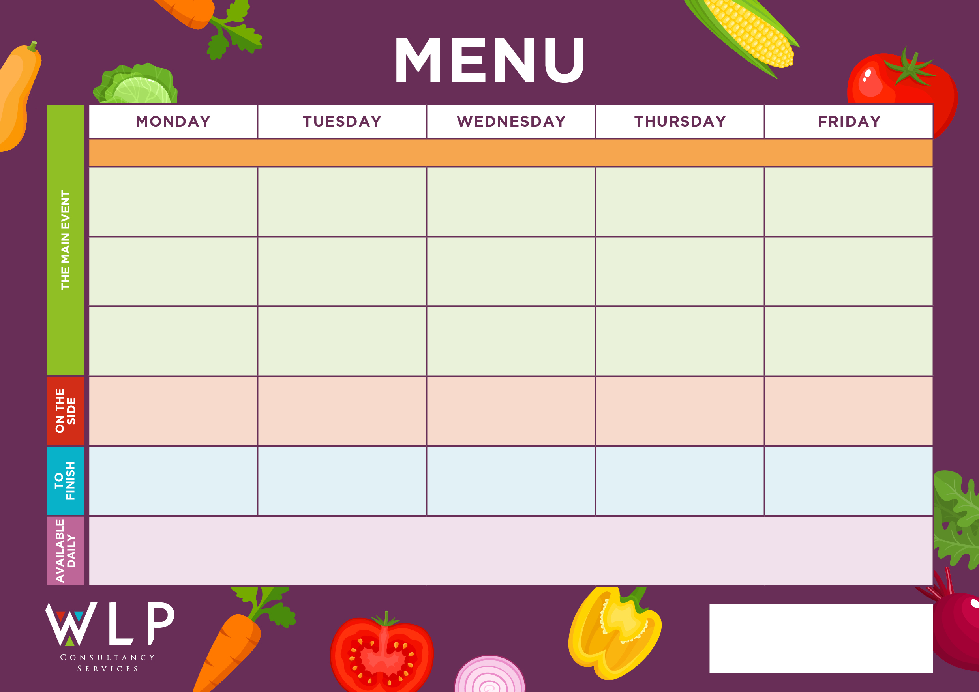

Vegan Crumb Schnitzel

Belgian Waffles with Fruit Slices

Hash Browns

Sweetcorn

Baked Beans

**‘Big Breakfast’**

Bacon, Sausage,

Scrambled Egg, Plum Tomatoes

Build your own Beef Burger with Bap & Seasonal Salad

**Myddle CE Primary School Menu Week 1 –1st Nov, 22nd Nov, 13th Dec, 17th Jan, 7th Feb 2022**

Chocolate Chip Cookie

Fruit Crumble & Custard

Vegan Roasted Vegetable Burrito

Vegan Pasta Neapolitan

Vegan Big Breakfast with Mushrooms

Vegan Pizza

Chicken Tender Fillets

‘**Big Veggie Breakfast’**

with Mushrooms

Cauliflower & Broccoli Gratin

Pasta Neapolitan

Mexican Chicken Fajita

Traditional Roast Turkey, Cranberry Sauce & Gravy

Selection of Oven Baked Fish

Fruit & Oat Cookie

***‘Pizza Bar’***

Ham & Mushroom Or

Cheese & Tomato

Roast & Creamed Potatoes

Carrots

Broccoli

Chipped Potatoes

Pasta

Baked Beans

Assorted Muffins

Fruit Platter

Jacket Potato with a Selection of Toppings, Grab bags, Freshly made bread, selection of salads. Fresh fruit, assorted yoghurts,

are readily available as an alternative to dessert of the day.

Additional vegetarian & vegan options are available upon request. Vegan desserts available.

Jacket Wedges

Sweetcorn

Peas

Rice

Pasta

Seasonal Vegetables