Dear Parents/Carers,
On Monday 28th June, we having an ‘Animal Day’ at school.
As each class in named after an endangered species, we wanted to take the opportunity to educate the children about their class animals.
During the day, the children will be completing various activities in order to learn more about each animal, find out the reasons why they are endangered as well as learning about what we can do to help.
We are aiming for each class to sponsor/adopt their class animal through the ‘World Wildlife Fund’ (WWF). In order to do this, we need your support. We would like, where possible, for each pupil to dress an animal for the day (this could be their class animal or their favourite animal) or pupils could come as a zoo keeper, animal park warden or an explorer. If each class can raise £36, this will cover an annual adoption for each endangered animal, so we are also asking if you could send in a small donation as well (minimum £1).
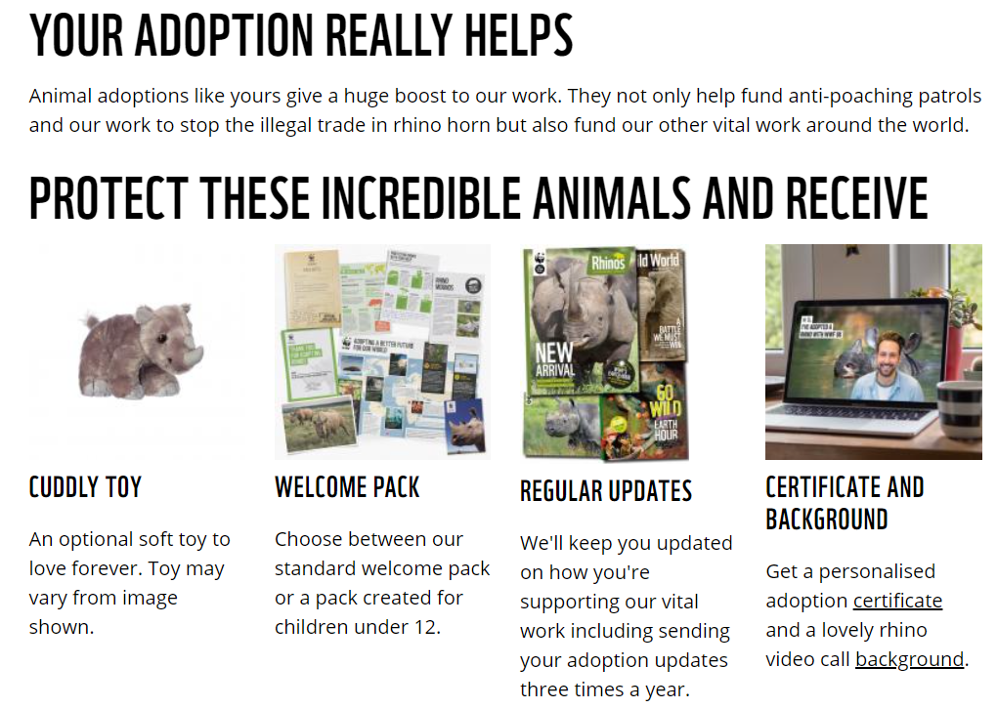
We know the children are going to be so excited to receive the welcome packs, especially the cuddly toy, which we will display around the school along with examples of work and photographs of the day. We will also share this one the class pages of the school website.

Thank you for continued support

Mr Glover

