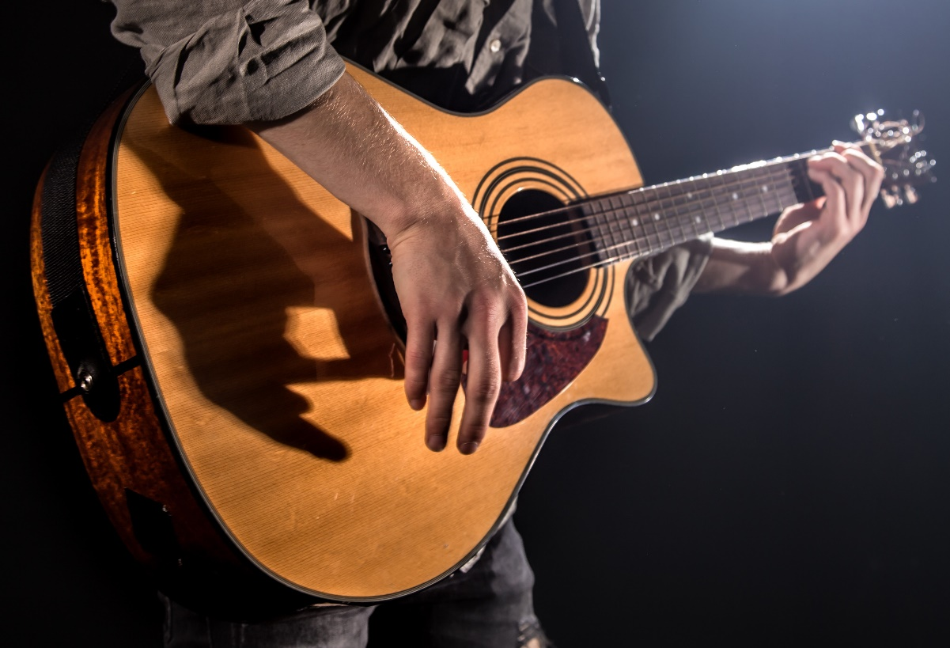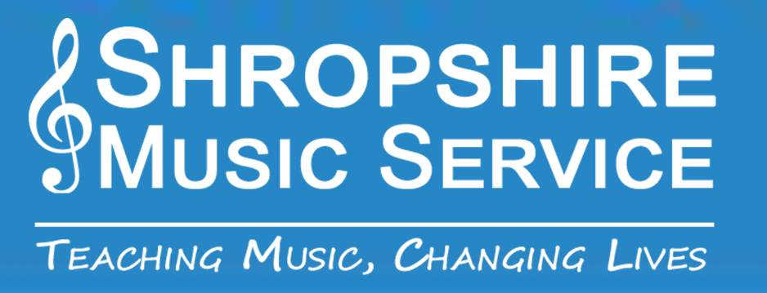

**Visit**  **or www.shropshiremusicservice.org.uk**

**for details.**

**Electric, Acoustic, Classical and Bass Guitar Lessons**

**Shropshire Music Service**