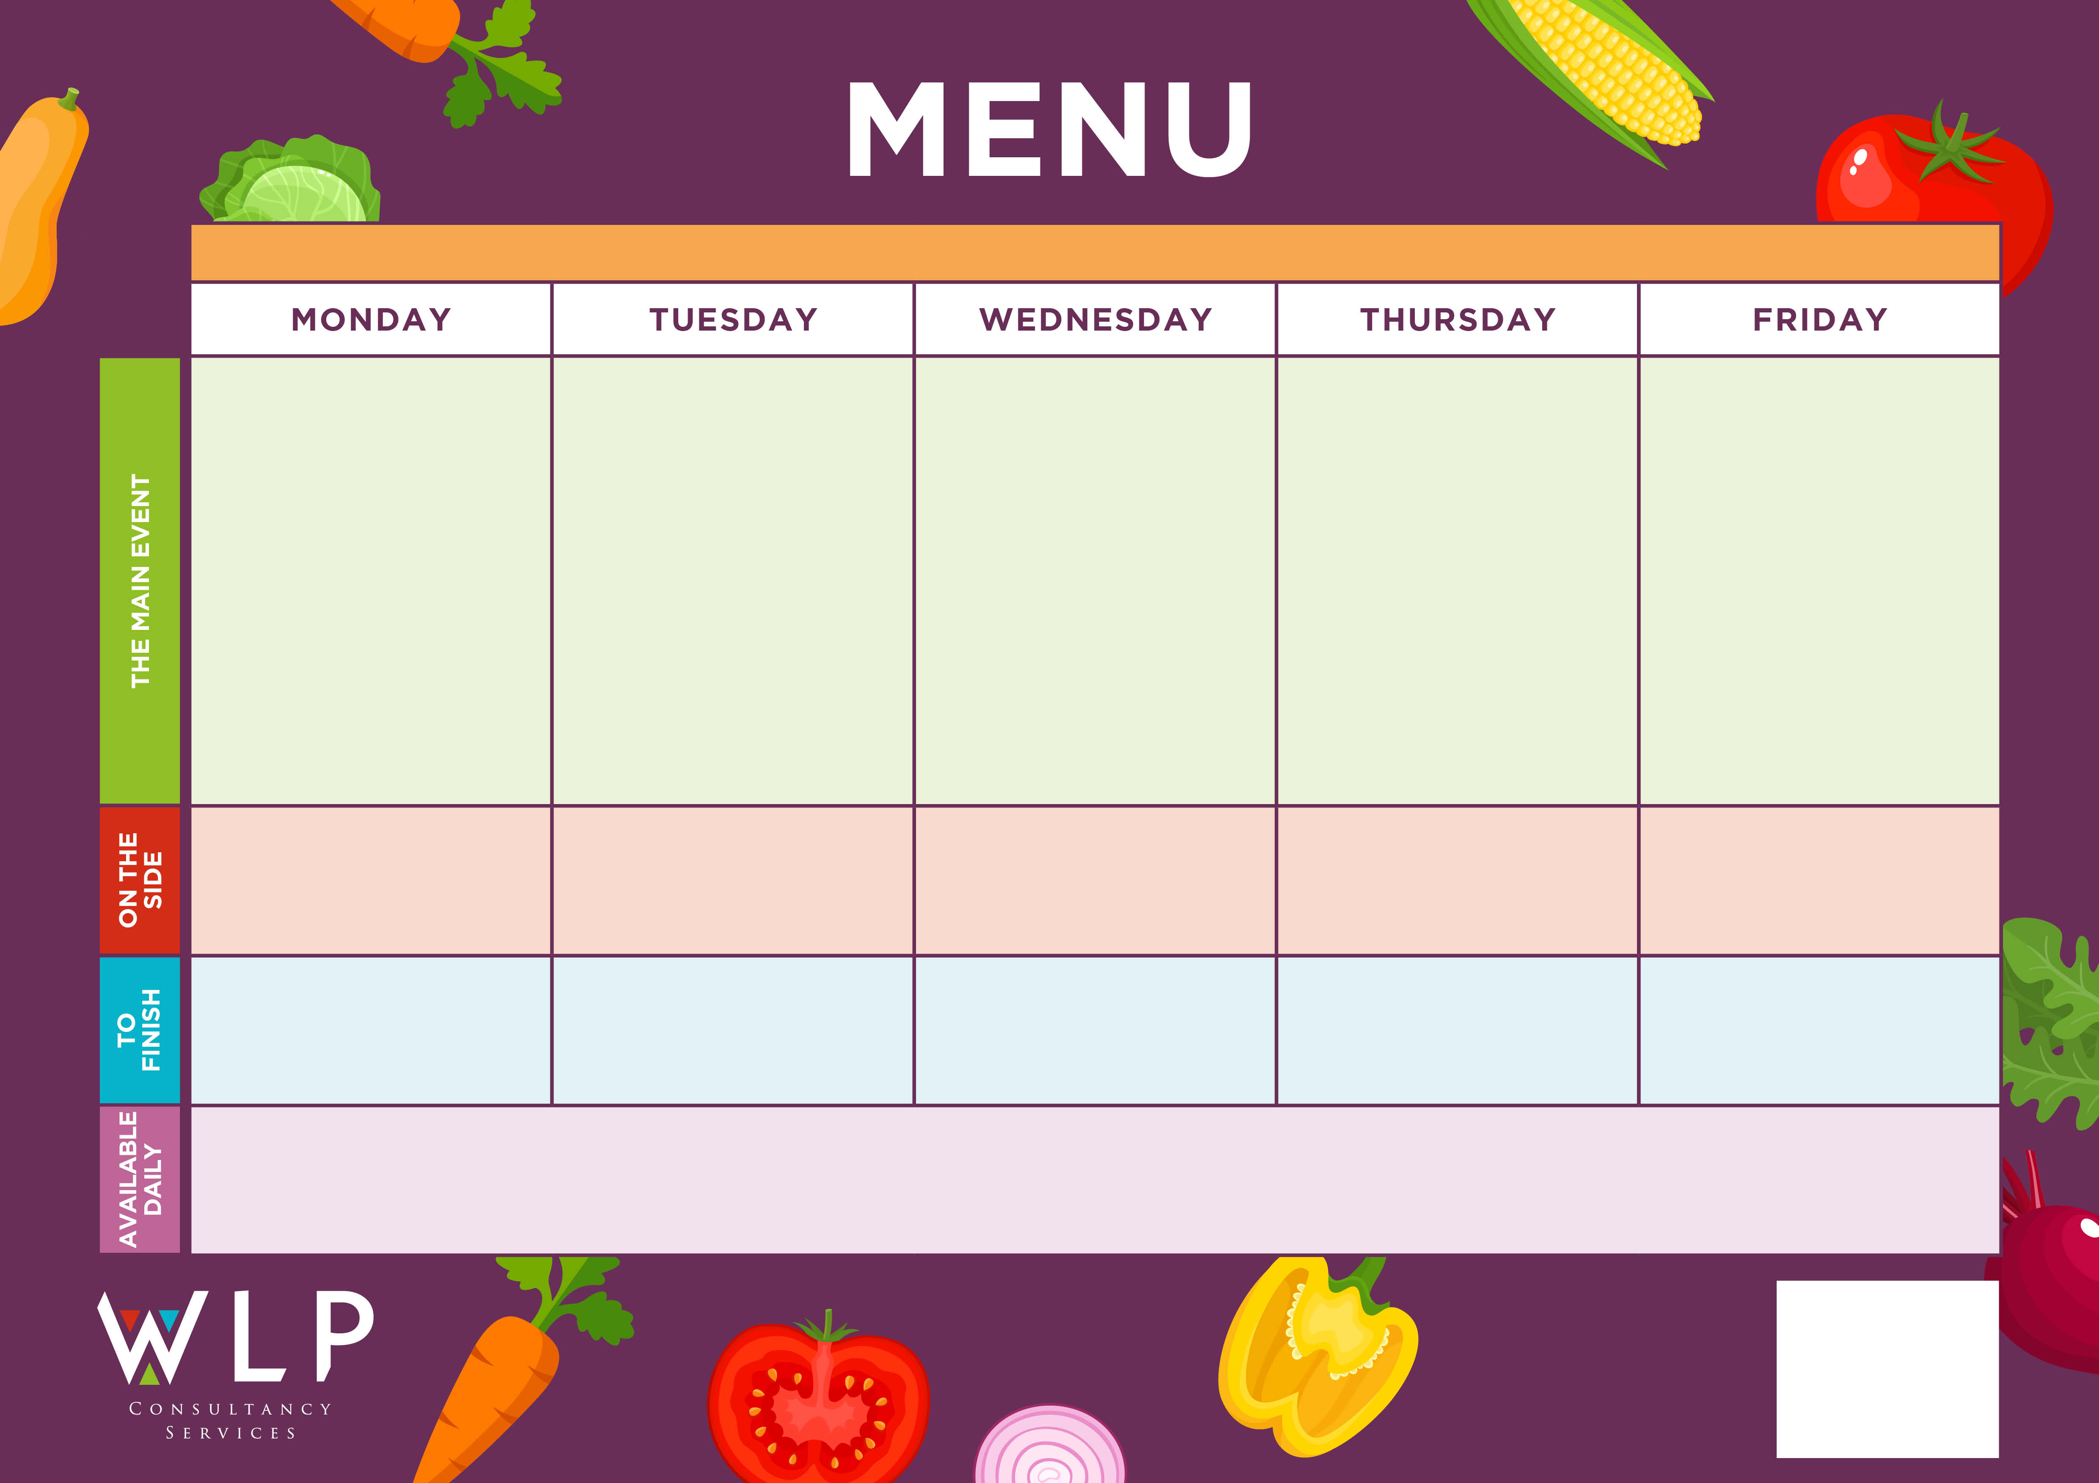

Selection of oven baked Fish

*‘Pizza Bar’*

Choice of Meat or Vegetarian Crispy Pizza

Vegetable baked Burger

Vegetarian Sausage with Yorkshire pudding & Gravy

Meatballs with Freshly Made Tomato Sauce

Sweet & Sour Quorn

Sweet & Sour Chicken

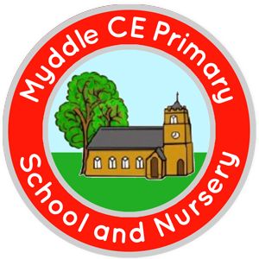

Freshly Baked Cookie

Vegetarian Meatballs with Tomato sauce

Gammon Steak with Pineapple

Traditional Roast

Beef with Yorkshire Pudding & Gravy

**MYDDLE CE PRIMARY SCHOOL MENU WEEK 2 w/c 15th March/ 19th April/ 10th May/ 7th 28th June/ 19th July**

Selection of Cookies / Shortbreads

Roast & Creamy Mash Potatoes

Carrots, Cabbage

Cauliflower

Fresh Seasonal Veg

Pasta

Seasonal Vegetables

Baked Beans

Noodles or Rice

Green Beans

Sweetcorn

Sweetcorn

Fruit Swirl Sponge

Chocolate & Mandarin Sponge & Chocolate Sauce

Butterfly Fairy Cakes

Frozen Yoghurt

Baby Potatoes

Seasonal Vegetables

Baked Beans

Chipped Potatoes

Pasta

Sweetcorn

Baked Beans

*Available Daily: Freshly Baked Bread, Healthy Salad Bar, Yoghurt & Fresh Fruit*

*A vegetarian/Vegan/Dairy Free option available daily*