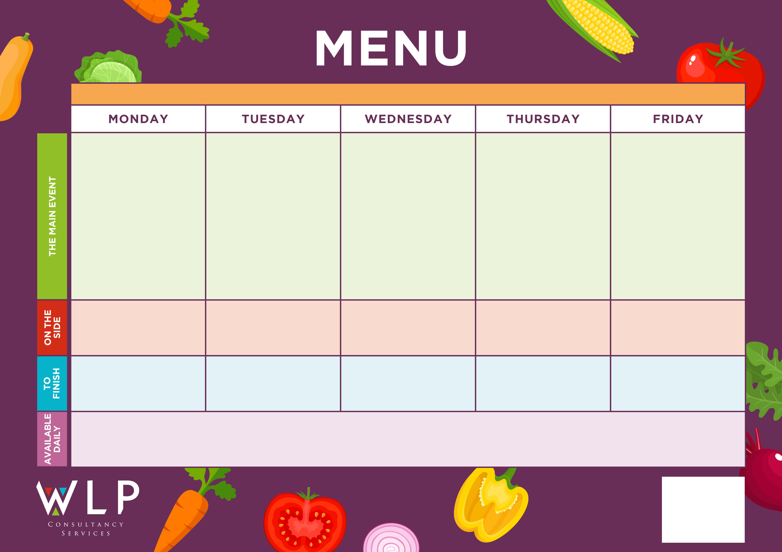

Selection of Oven Baked Fish

*‘Pizza Bar’*

Selection of meat & Vegetarian crispy based pizza

‘Big veggie Breakfast’

with Mushrooms

‘Big Breakfast’

Bacon, Sausage, Scrambled Egg, Plum Tomatoes

Build your own Beef Burger with Bap and Seasonal Salad

Hash Browns

Sweetcorn

Baked Beans

Chipped Potatoes

Pasta

Baked Beans

Mexican Chicken Fajita

Pasta Neapolitan

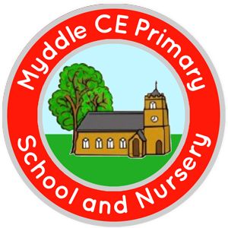

Fruit & Oat Cookie

Cauliflower & Broccoli Gratin

Chicken Tender Fillets

Traditional Roast

Turkey, Cranberry Sauce & Gravy

**MYDDLE CE PRIMARY SCHOOL MENU WEEK 1 w/c 8th 29th March/3rd 24th May /21st June / 12th July**

Belgian Waffles with Fruit Slices

Roast & Creamed Potatoes

Carrots

Broccoli

Jacket Wedges

Sweetcorn

Peas

Rice or Pasta

Seasonal Vegetables

Chocolate Chip Cookie

Fruit Crumble & Custard

Assorted Muffins

Fruit Platter

*Available Daily: Freshly Baked Bread, Healthy Salad Bar, Yoghurt & Fresh Fruit*

*A vegetarian/Vegan/Dairy Free Option will be available daily.*