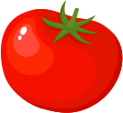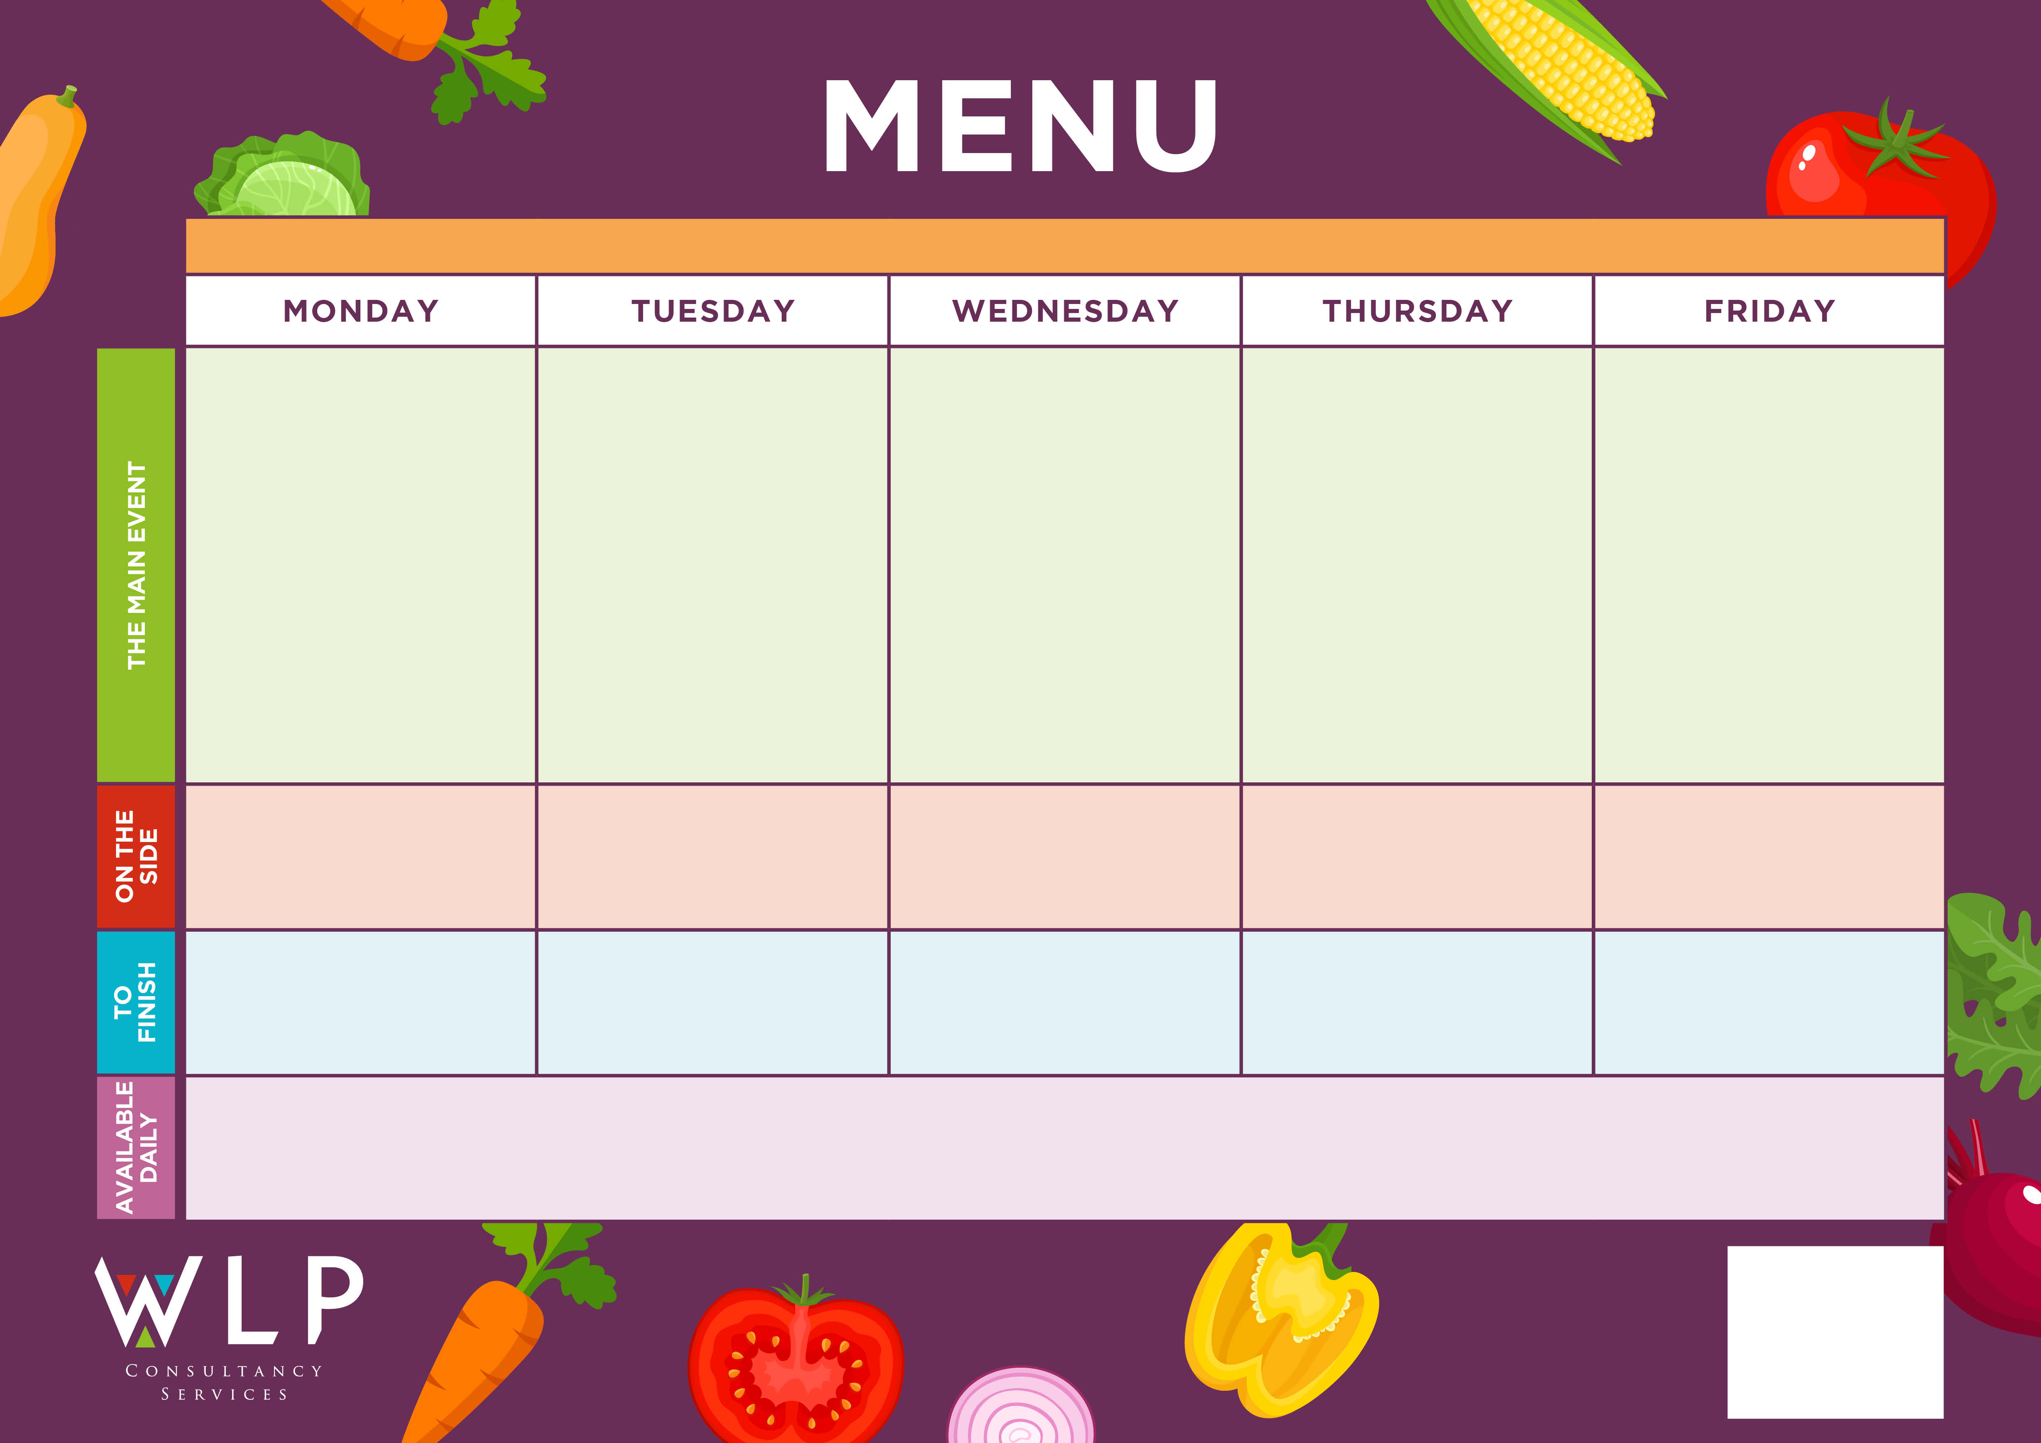

*‘Big Breakfast’*

Bacon, Sausage, Scrambled Egg, Plum Tomatoes

Hash Browns

Baked Beans

Macaroni Cheese with Garlic Bread

*‘Big Veggie Breakfast’*

With Mushrooms

Chicken Breast Tenders

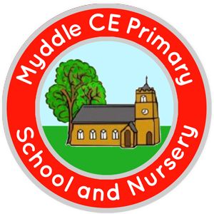

Ginger Sponge & Custard

Spaghetti Bolognaise

or Lasagne

Filled Jacket Potato

(Cheese/Cheese&Beans/ Tuna mayo)

Quorn Fillet & Gravy

Oven Baked Salmon Fishcake

Traditional Roast

Chicken with Stuffing & Gravy

‘Pizza Bar’

Choice of Meat or Vegetarian Crispy Pizza

**MYDDLE CE PRIMARY SCHOOL MENU WEEK 3 w/c 22nd March /26th April/17th May/ 14th June/ 5th July**

Pancakes with Fruit Slice

Roast & Creamed Potatoes

Carrots

Peas

Cauliflower Cheese

Garlic Bread Slice

Peas

Carrots

Potato Wedges

Green Beans

Sweetcorn

Fruit Jelly

Ice Cream

Apple Crumble & Custard

Shortbread

Chipped Potatoes

Pasta

Peas

Baked Beans

Peas

Carrots

*Available Daily: Freshly Baked Bread, Healthy Salad Bar, Yoghurt & Fresh Fruit*

*A vegetarian/Vegan/Dairy Free Option available daily.*