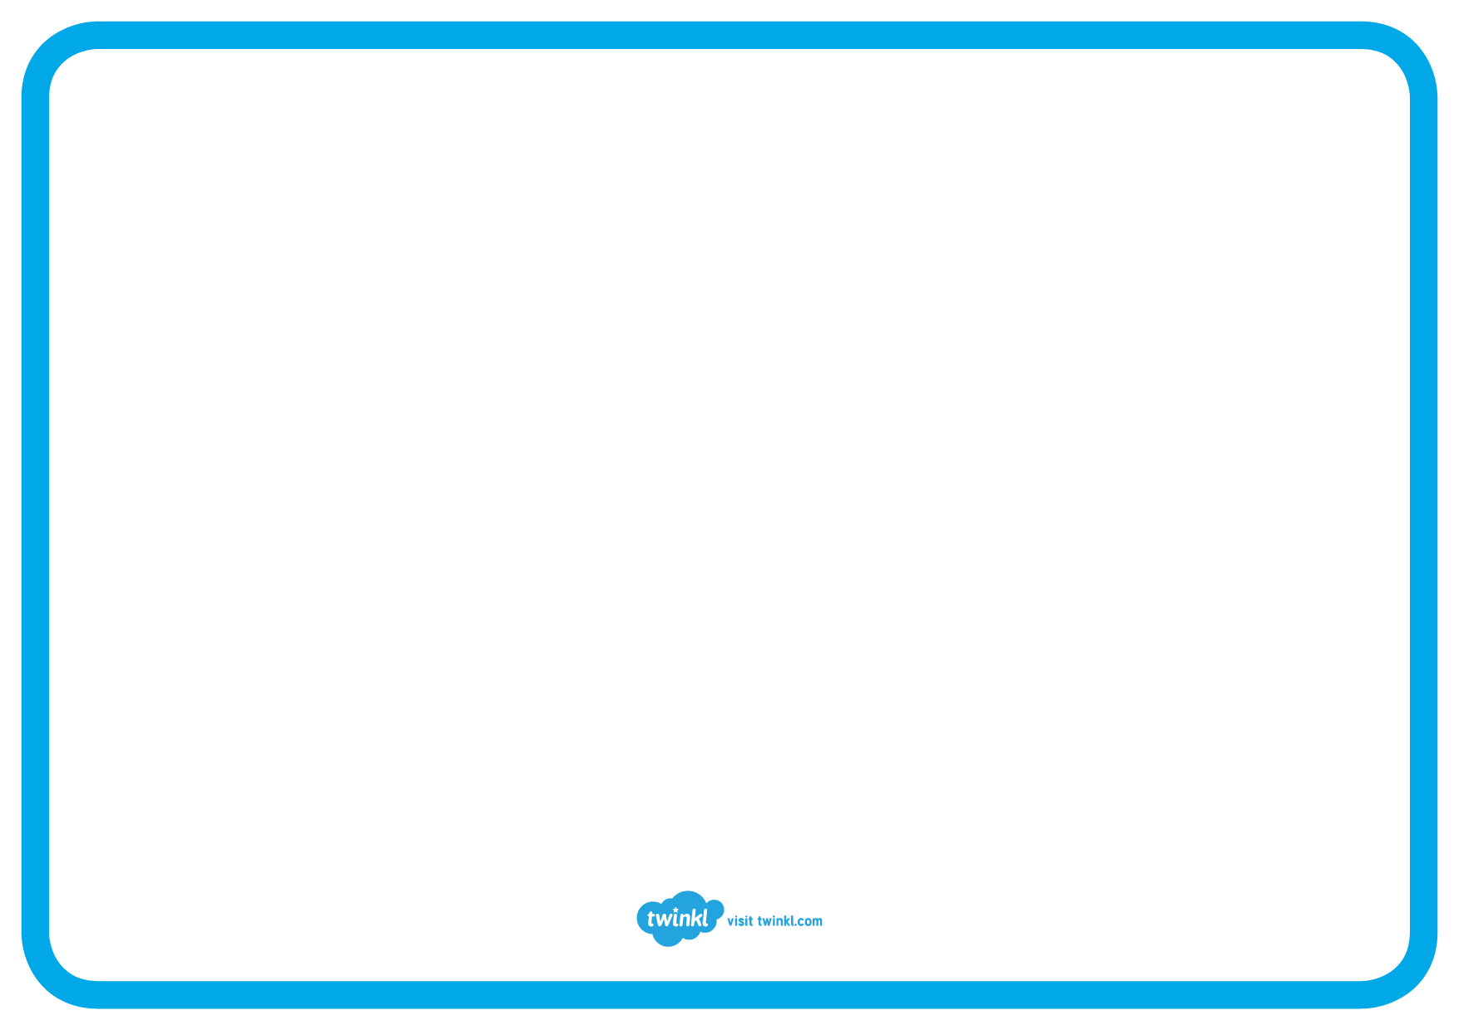
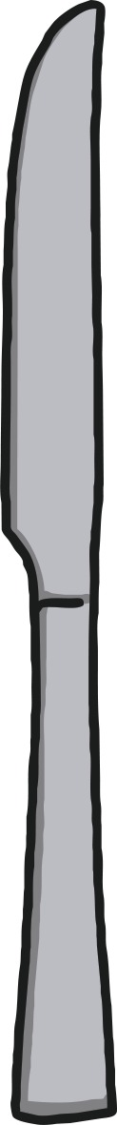
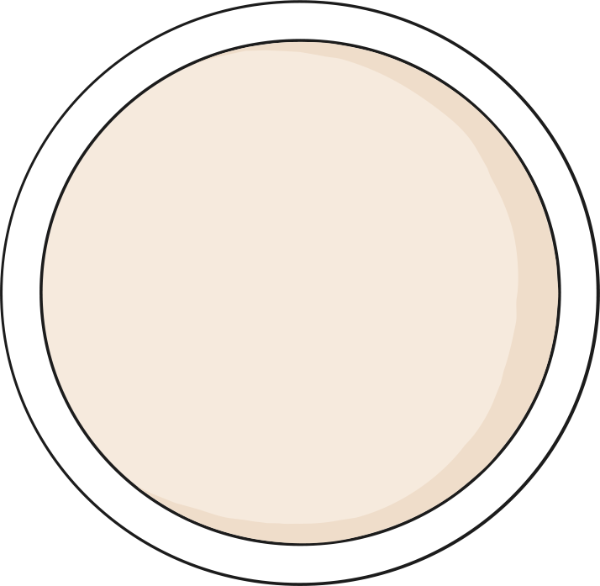
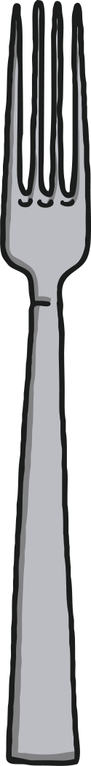
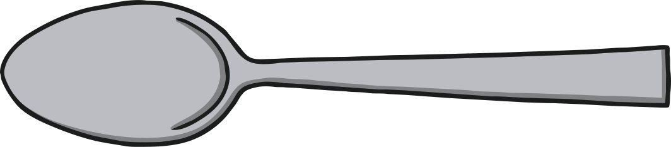
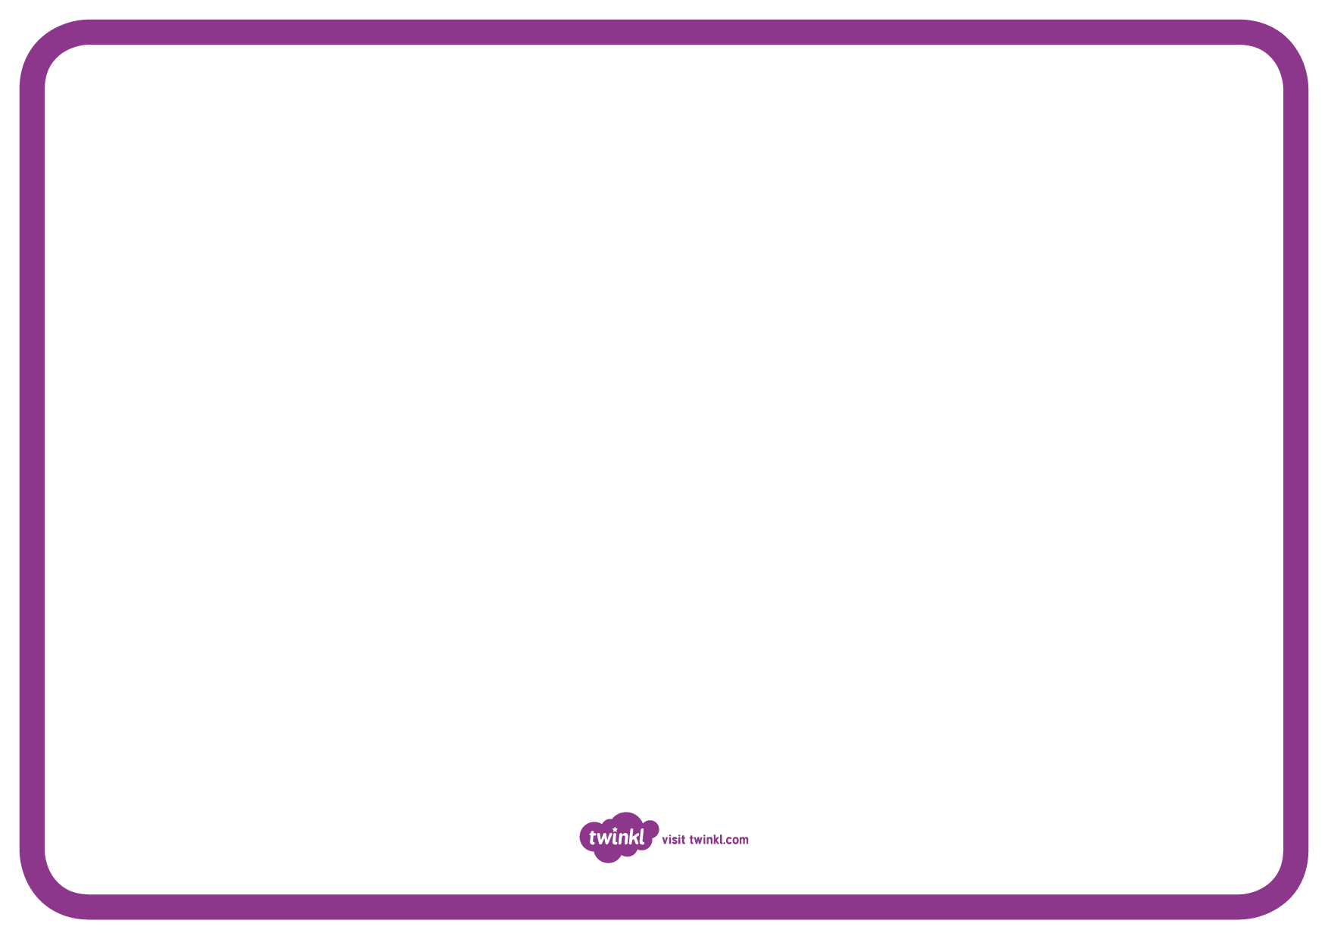
If my Teacher came for tea!
Have a little think and draw the food that you would give to me or Fran if we came for tea at your house!!

