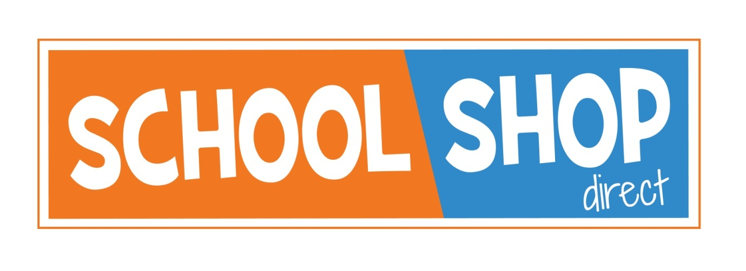

Due to government restrictions relating to Covid, as non essential retail, our main retail outlet will remain closed until approx 12th April 2021

We will still be open for on line, telephone and email orders, and we also operate a click and collect service from our main Shrewsbury shop. Please call 01743 440 449 for any assistance.

We apologise for any inconvenience this may cause, but we will be fully available to contact and assist with any items that are needed.

If you have any queries, please do contact us.

Regards

School Shop Direct

17-18 Sundorne Trade Park, Featherbed Lane, Shrewsbury, SY1 4NS
Telephone: 01743 440449
E-mail: info@schoolshopdirect.co.uk
www.schoolshopdirect.co.uk

