[Leopard Seal](http://en.wikipedia.org/wiki/Leopard_Seal" \t "NEW) - The leopard seal gets its name because of the colour patterns on its fur and its fierce nature. Their favourite food is penguins but they also feed on fish, krill, and squid.

[Emperor Penguin](http://en.wikipedia.org/wiki/Emperor_Penguin)s are the biggest of all of the penguins! They are the only living species that have their babies during the Antarctic winter. Without a nest, the male keeps the egg warm by holding it on his feet under a layer of skin for 2 months! Unbelievable! What a Dad!!

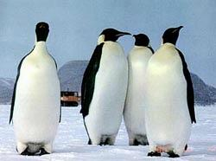

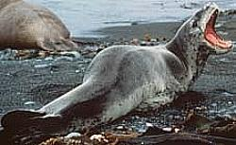

**Antarctic Explorers:**

Roald Amundsen was an explorer of the North and South Poles. He led the first expedition to reach the South Pole and was the first person to visit **both** the North and South Pole. The following are some fun facts about Roald Amundsen:

* Amundsen left a flag on the North and South Pole to leave his mark.
* At one point he was attacked and nearly killed by a polar bear.
* Roald learned valuable lessons of survival during these early trips to The North and South Pole. He even ate seal meat when he ran out of food!
* Roald was killed in a plane crash on an exhibition.

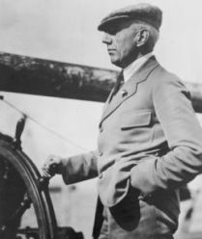

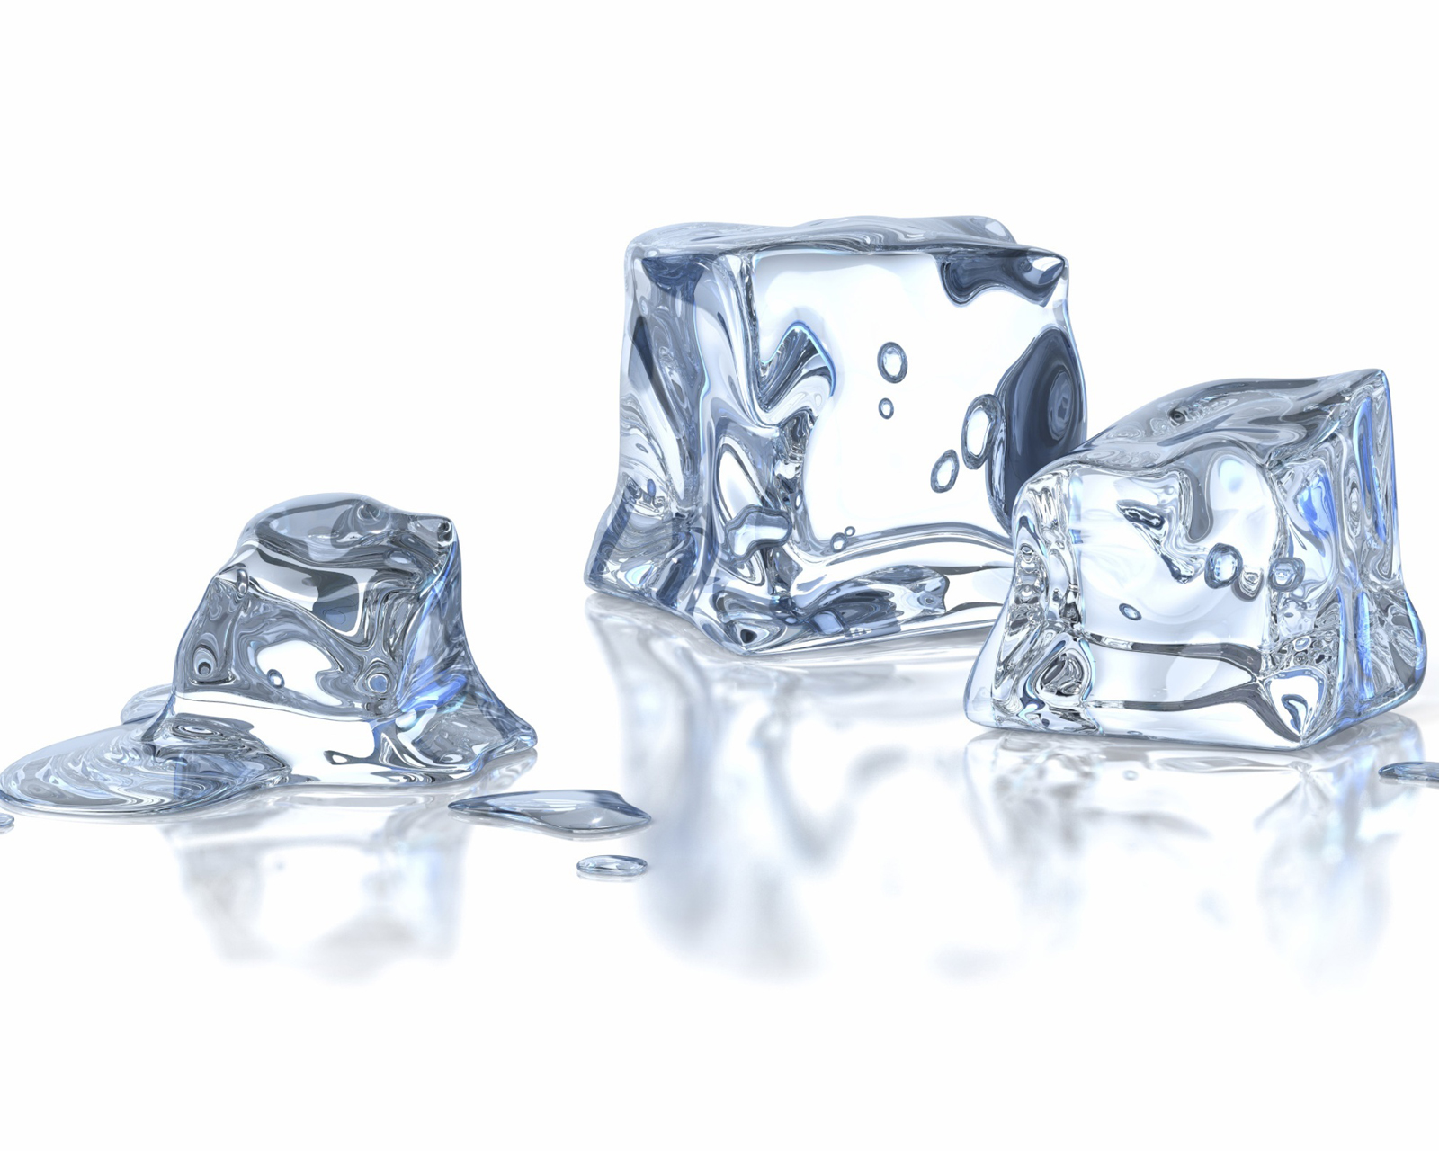

**The ice is melting….**

Polar ice caps are huge, thick sheets of ice that are found in both The North and South Pole. Scientists are worried that as the Earth continues to get hotter and hotter because of pollution, the ice will melt away. This would mean there would be flooding around the world and many animals and plants in the sea would die.

**Roald Amundsen steering his ship.**

Antarctica is the world's largest desert because it has so little rain and very little grows there. Antarctica is a unique continent that is full of ice and snow but there are some very interesting things that you might want to know about it.

Antarctica

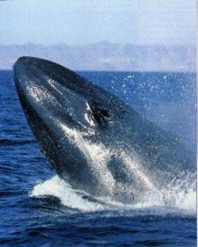

[Blue Whale](http://www.enchantedlearning.com/subjects/whales/species/Bluewhale.shtml) - named for its blue-gray colour, this huge whale may grow to be roughly 100 feet long and weigh more that 120 tons! The tongue of the blue whale can be as big as a car! The blue whale is the loudest animal on earth!

[Orcas](http://en.wikipedia.org/wiki/Orca) – Also known as Killer whales, the can live in different temperatures which means they can live all over the world

[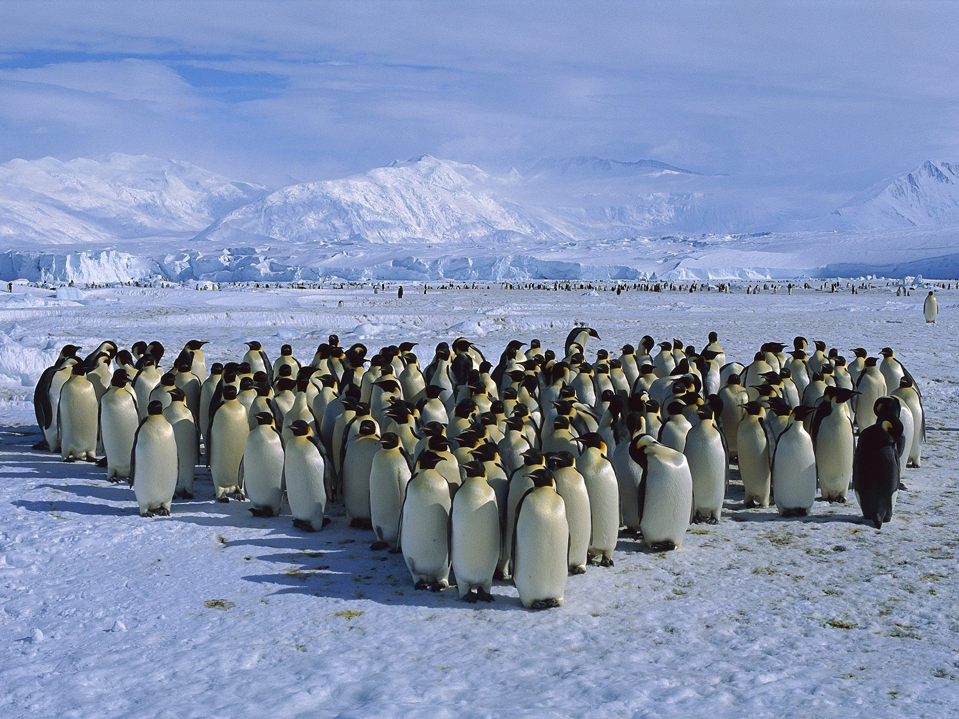](http://www.google.co.uk/url?sa=i&rct=j&q=&esrc=s&source=images&cd=&cad=rja&docid=3Dcxt25BXnjcuM&tbnid=FwDasHHhhPg5qM:&ved=0CAUQjRw&url=http://iloveecology.wordpress.com/2010/10/18/emperor-penguins-how-they-survive-antarctica/&ei=Cjv5UvH0G8-ThQeUxYGgCQ&bvm=bv.60983673,d.ZG4&psig=AFQjCNG2Rdrxt-Bhr8sg2bpHRgpz6ceUfA&ust=1392151622342091)

**Wildlife:**

There are no animals that live on the land in the Antarctica! However, the ocean is home to many living creatures! Below are some facts about these animals:

Penguins are the only birds that live here all the time.

[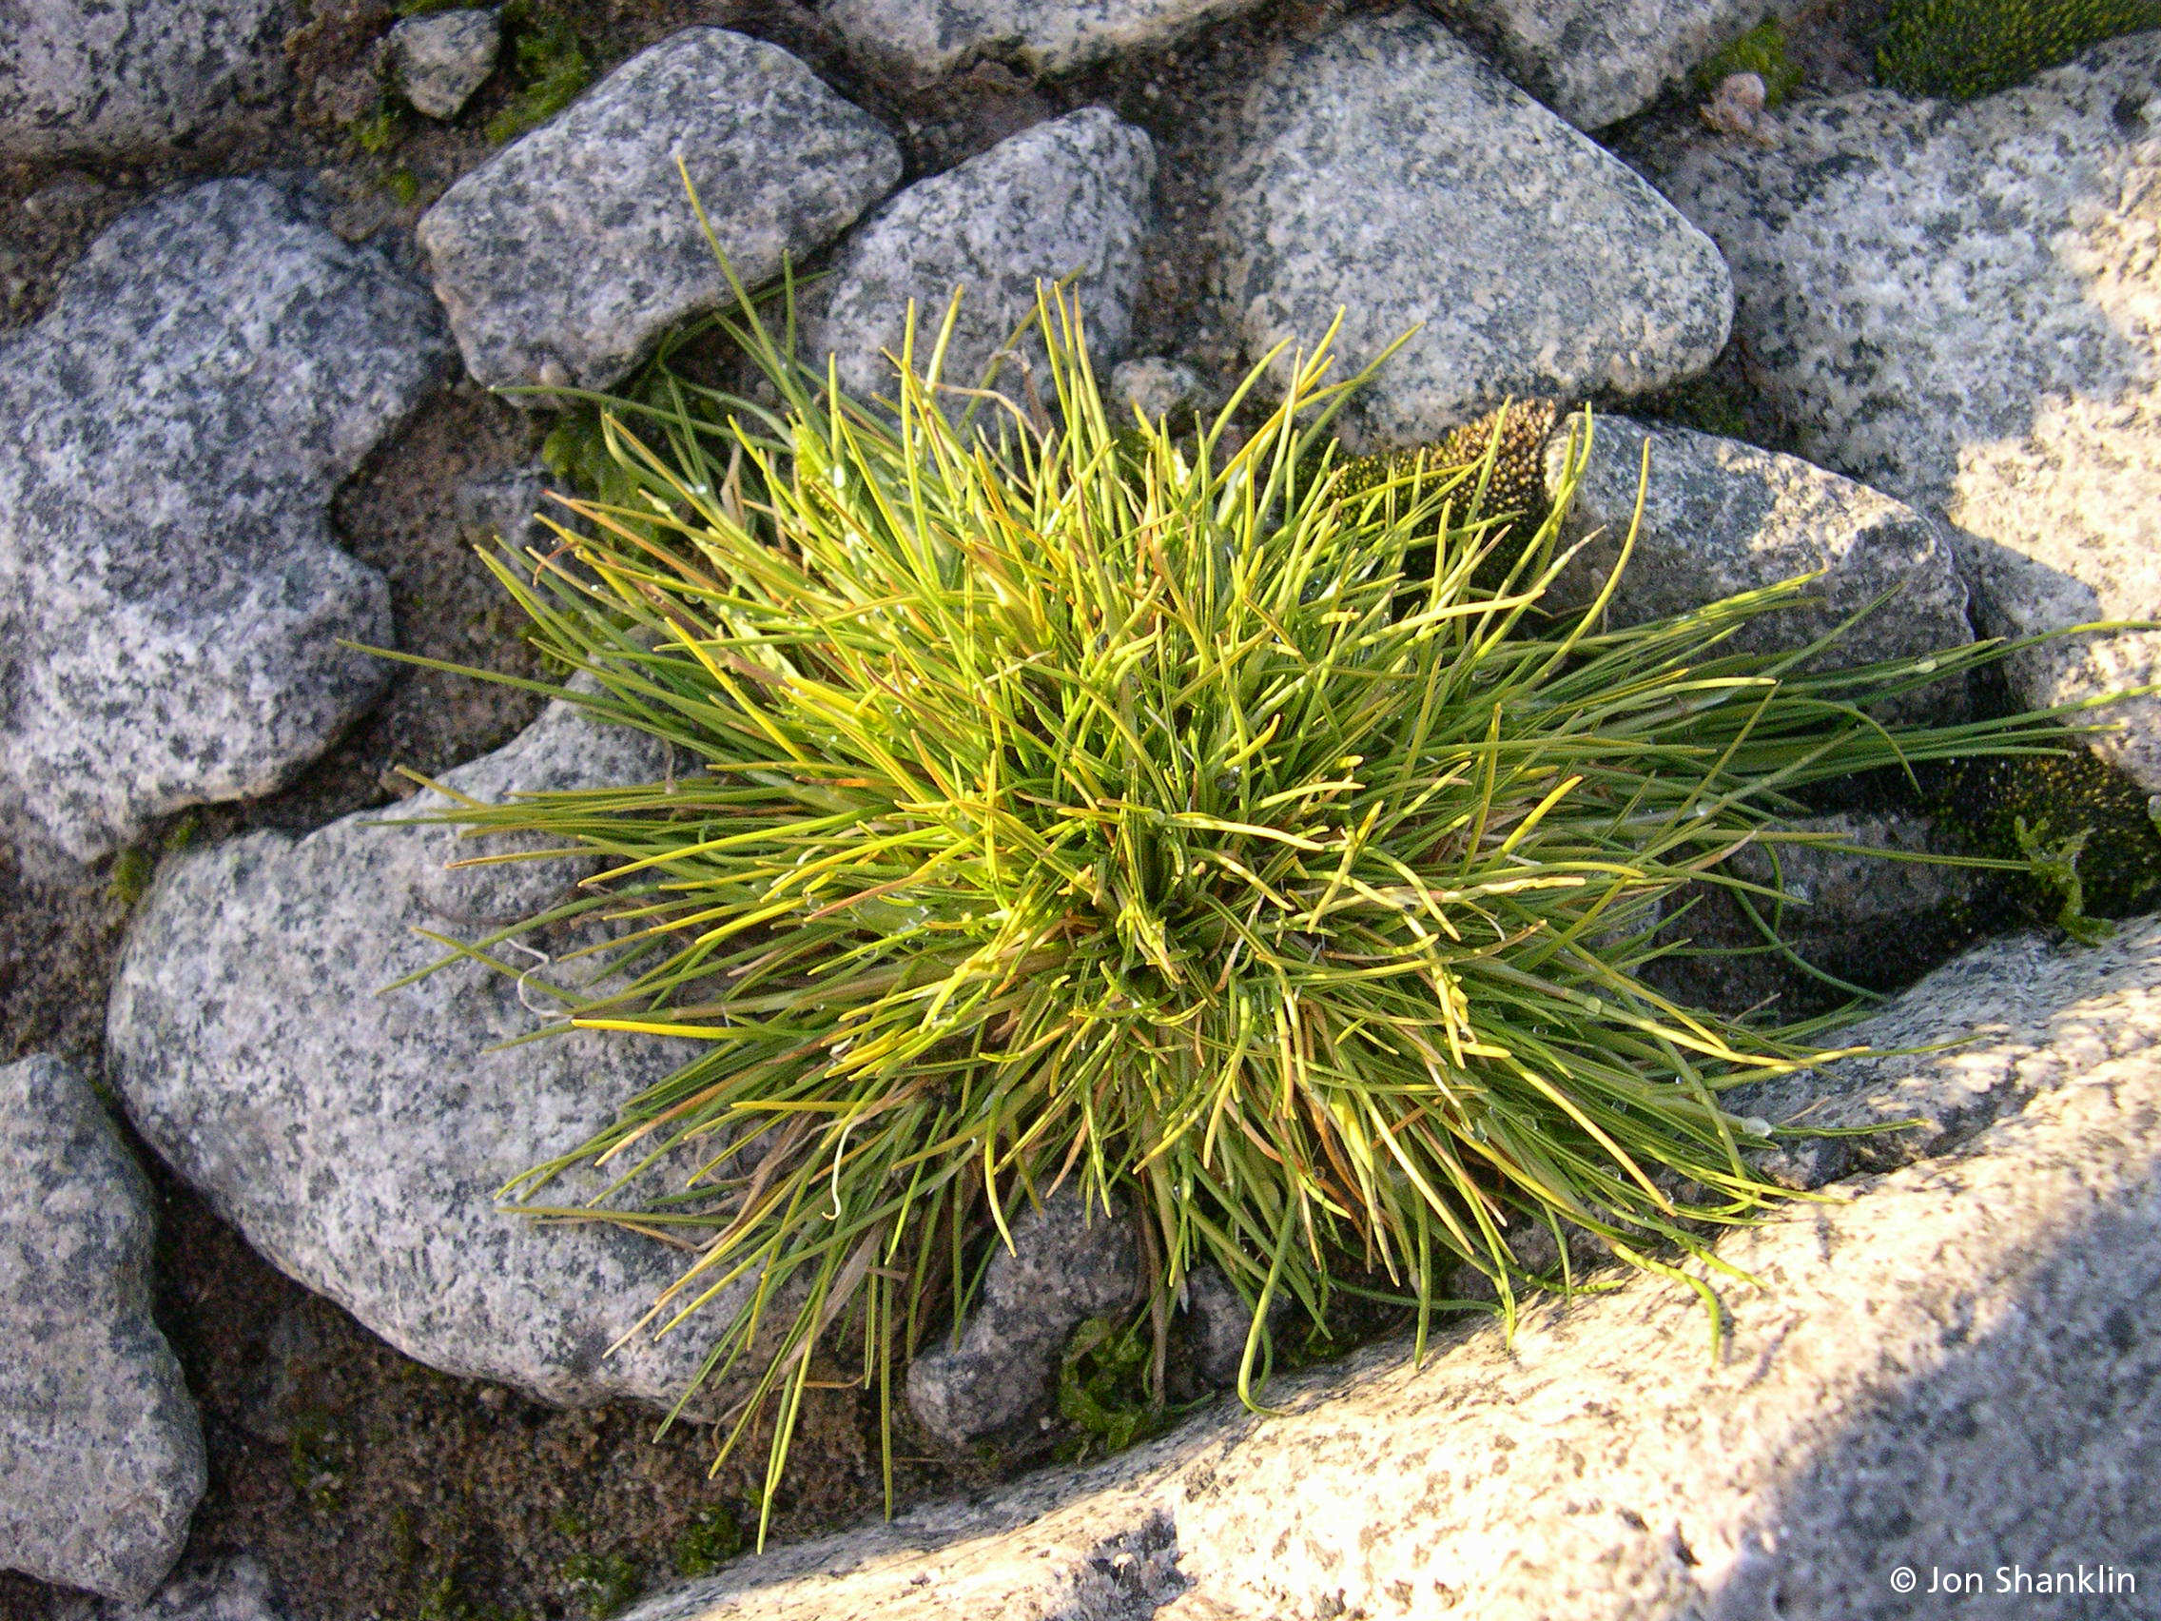](http://www.google.co.uk/url?sa=i&rct=j&q=&esrc=s&source=images&cd=&cad=rja&docid=Ro9-dHy5im_PLM&tbnid=nWrIYL1DnQp0QM:&ved=0CAUQjRw&url=http://herbaria.plants.ox.ac.uk/bol/bas&ei=6Tn5UunFM9CUhQeNpIC4Dg&bvm=bv.60983673,d.ZG4&psig=AFQjCNE1ArpbftR8o5McbLdU7xDzg-uE_A&ust=1392151337696991)

**Plant Life:**

There is not a lot of plant life because of the extreme cold temperatures and lack of sunlight. There are, however, some plants that grow here but they only last for a few weeks or even just for a few days in summer.

[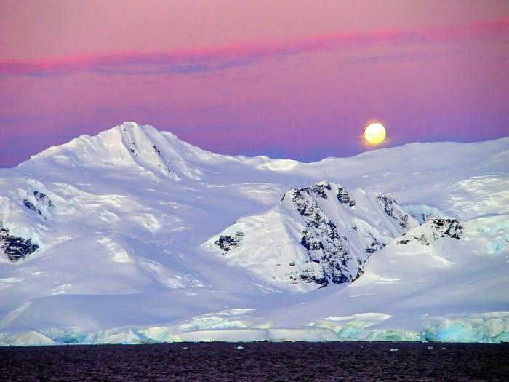](http://www.google.co.uk/url?sa=i&rct=j&q=&esrc=s&source=images&cd=&cad=rja&docid=USih1j0pe_e3IM&tbnid=yMBtg6haSKpEsM:&ved=0CAUQjRw&url=http://www.puretravel.com/itineraries/1302&ei=IDn5UofaAciqhAfV0YD4Cw&bvm=bv.60983673,d.ZG4&psig=AFQjCNG7zk2lsybxMBUEGWXm2fP6SCwIng&ust=1392151182630894)

**Life in Antarctica:**

There are just two seasons in Antarctica: a very short cold summer and a very long, colder winter. There are no local people in Antarctica, only scientists and explorers. It is just too cold for people to live there all the time!