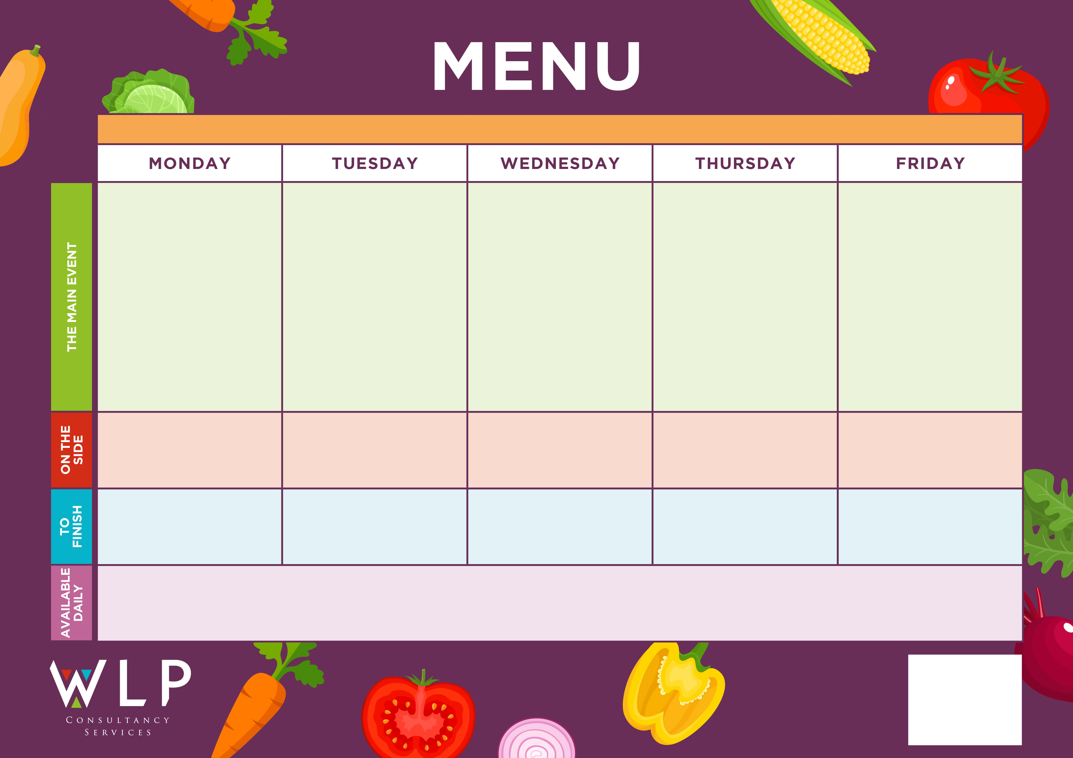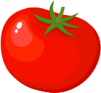

**FINAL WEEK OF  
 TERM**





Pasta Neapolitan OR Cheese Pasty

Selection of Oven Baked Fish

Selection of meat & Vegetarian crispy based pizza

Sausages

Mashed potato, carrots & Peas

Chips

Pasta

Baked Beans

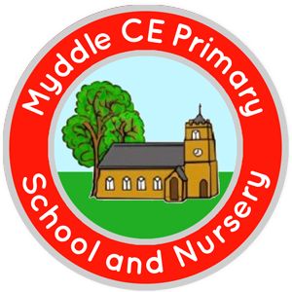

Fruit & Oat Cookie

Traditional Roast

Turkey & Gravy

**MYDDLE CE PRIMARY SCHOOL MENU WEEK 14/12/2020**

Ice-Cream

Roast & Creamed Potatoes

Carrots

Broccoli

Garlic Bread

Sweetcorn

Pasta

Seasonal Vegetables

Chocolate Chip Cookie

Apple Crumble & Custard

Assorted Muffins

*Available Daily: Freshly Baked Bread, Healthy Salad Bar, Yoghurt & Fresh Fruit*

*A vegetarian/Vegan/Dairy Free Option will be available daily.*