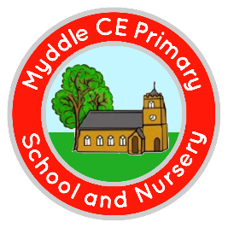
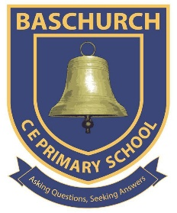

Executive Headteacher: Mrs C M Williams

Thursday 10 December 2020

Dear Parents/Carers,

The Department for Education have asked us to make you aware of the following information and relevant arrangements regarding positive COVID-19 cases in the holidays:

- If your child develops symptoms within 48 hours of being in school and tests positive for coronavirus (COVID 19) during the first 6 days after teaching ends (Saturday 19 December to Thursday 24 December), the school will be asked to assist in identifying close contacts and advising self-isolation, as the individual may have been infectious whilst in school.

- Where a pupil or staff member tests positive for coronavirus (COVID-19), having developed symptoms more than 48 hours since being in school, the school should not be contacted. Parents and carers should follow contact tracing instructions provided by NHS Test and Trace.

- School staff are not asked to remain on-call or conduct any contact tracing more than 6 days after the final day of teaching. Where a schools last teaching day is on Friday 18 December, there should be no pupil contact tracing asks beyond Thursday 24 December.
For the first 6 days after the end of term, schools are not asked to be on-call at all times. Our school admin team will check the admin emails between 9-10am each day from Saturday 19 December to Thursday 24 December.

Where pupils are required to self-isolate due to testing positive or due to contact with a positive case after Thursday 24 December, we do not need to be informed about their absence until Monday 04 January (PD Day).

When do I need to contact school?

If your child develops symptoms of COVID-19 within 48 hours of being in school and then tests positive for COVID-19, please email the admin address (admin@myddle.shropshire.sch.uk) as soon as possible with the following information: -
- Pupil Name and Class
- The date the symptoms began
- The date the test was carried out
- The date the result was received
We will then use this information to contact Public Health England. If your child’s test result comes back negative, you do not need to inform school.
If we contact you to ask you to isolate, whilst I know this may affect Christmas plans, we would ask that you do follow this guidance to support the whole community and also, hopefully a successful return to school after the Christmas break.

Emails will be checked between 9-10am each day.

If you have any questions, please contact the school office.

Yours sincerely

Mrs C Williams
Headteacher

