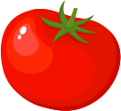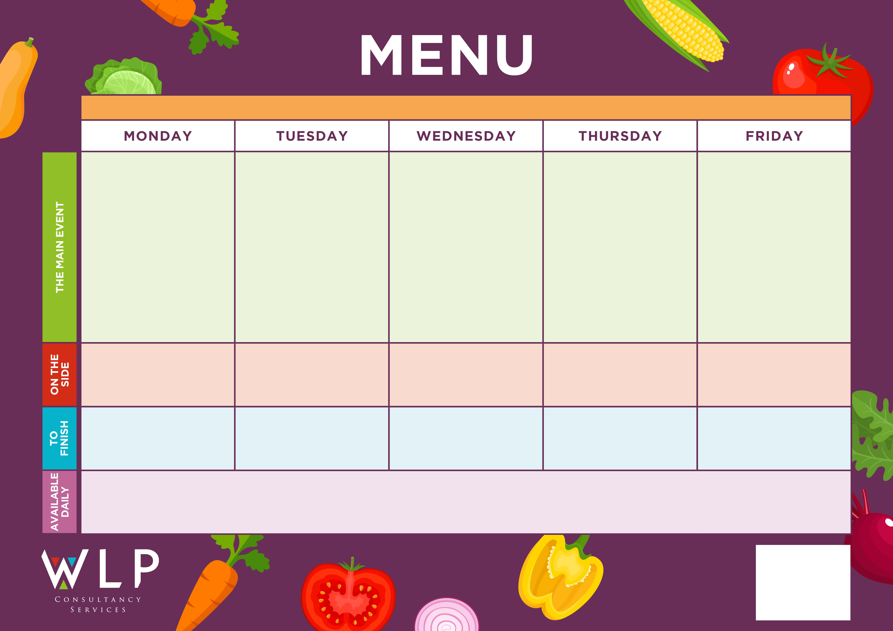

*‘Big Breakfast’*

Bacon, Sausage, Scrambled Egg,

Hash Browns

Baked Beans

Macaroni & Cheese

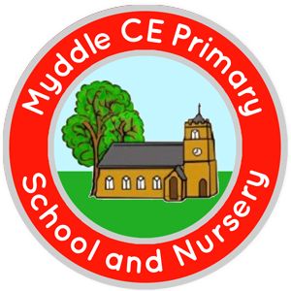

Shortbread

Spaghetti Bolognaise

Traditional Roast

Chicken & Gravy

‘Pizza Bar’

Choice of Meat or Vegetarian Crispy Pizza

**MYDDLE CE PRIMARY SCHOOL MENU WEEK 3 16/11/2020 & 07/12/2020**

Pancakes with Fruit Slice

Roast & Creamed Potatoes

Carrots

Peas

Cauliflower Cheese

Peas

Carrots

Garlic Bread

Beans

Sweetcorn

Chocolate cake slice

Syrup sponge & Custard

Assorted Muffins

Chips

Peas

Baked Beans

Peas

Carrots

*Available Daily: Freshly Baked Bread, Healthy Salad Bar, Yoghurt & Fresh Fruit*

*A vegetarian/Vegan/Dairy Free Option available daily.*