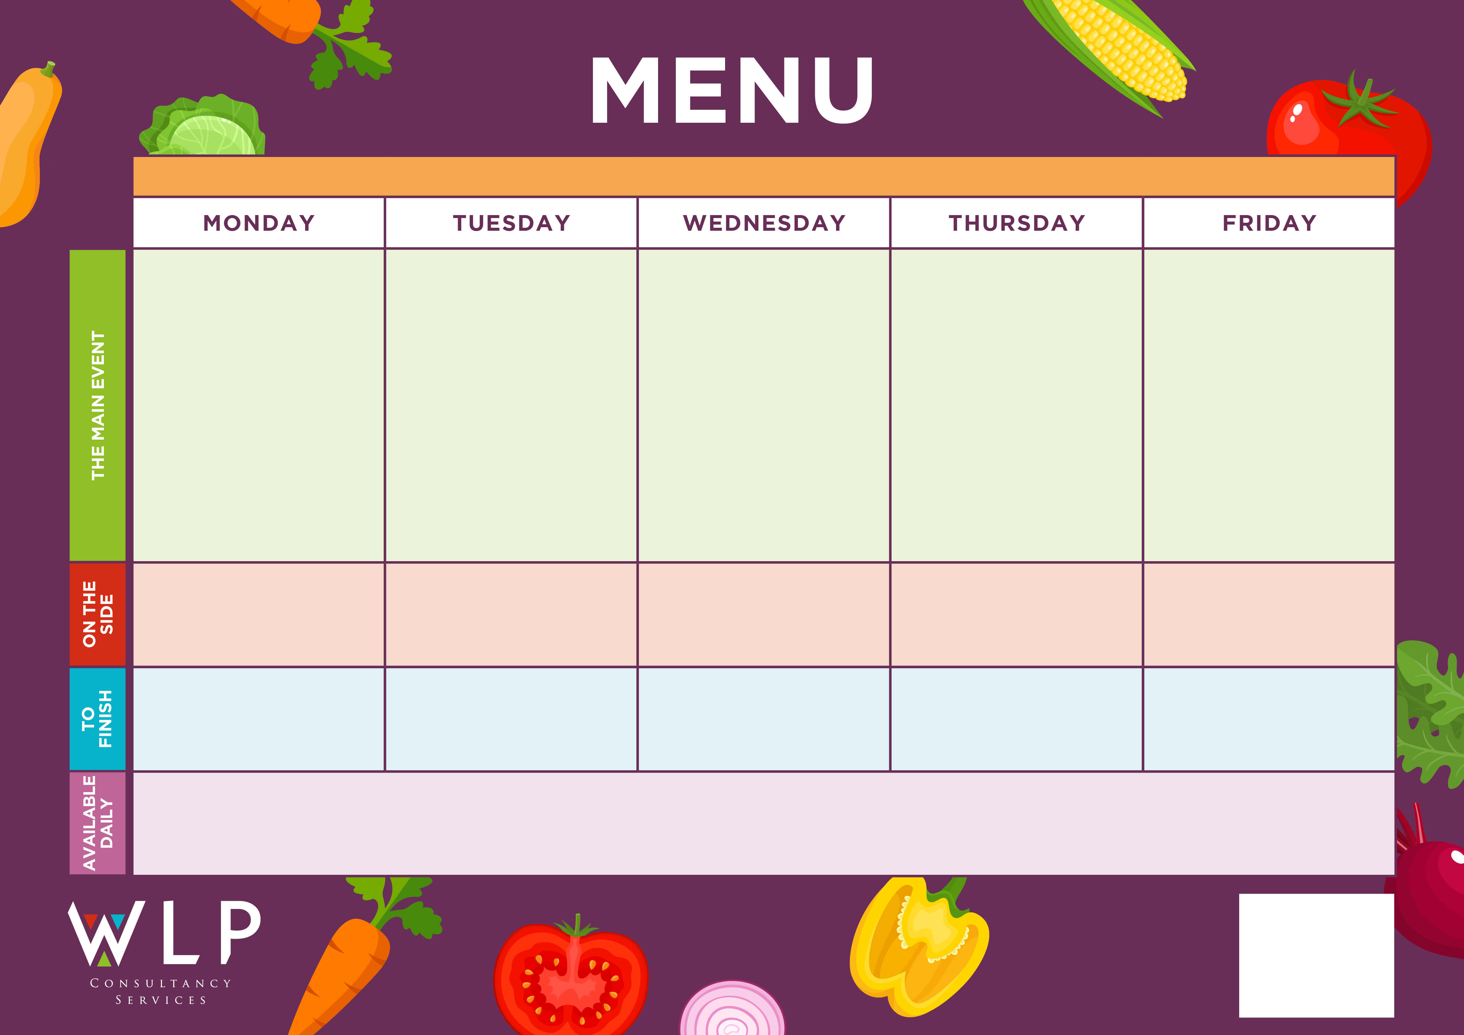

*‘Pizza Bar’*

Choice of Meat or Vegetarian Crispy Pizza

Meatballs with Freshly Made Tomato Sauce

Sweet & Sour Chicken

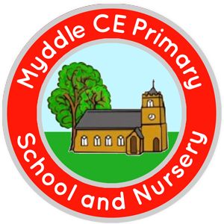

Jam Cookie

Fish Cakes

Traditional Roast

Beef with Yorkshire Pudding & Gravy

**MYDDLE CE PRIMARY SCHOOL MENU WEEK 2 09/11/2020 & 30/11/2020**

Ice-Cream

Roast & Creamy Mash Potatoes

Carrots,

Cauliflower

Fresh Seasonal Veg

Pasta

Peas

Baked Beans

Noodles

Green Beans

Sweetcorn

Sweetcorn

Raspberry Swirl Sponge

Chocolate Orange Sponge & Chocolate Sauce

Choc Chip Cookie

Pasta

Peas, Beans

Chips

Sweetcorn

Baked Beans

*Available Daily: Freshly Baked Bread, Healthy Salad Bar, Yoghurt & Fresh Fruit*

*A vegetarian/Vegan/Dairy Free option available daily*