Maths Puzzle 1 - Prison Cells
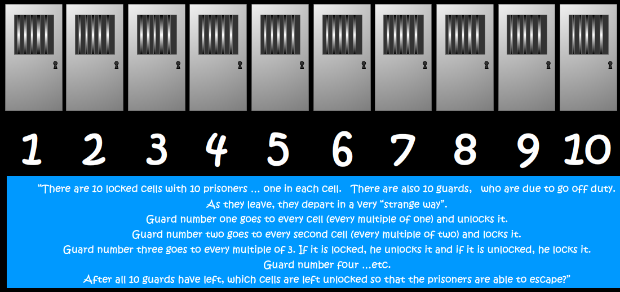
Make any jottings below to show how you've reached your final answer.
Good luck!

