HELP JANE GOODALL SAVE THE CHIMPANZEES

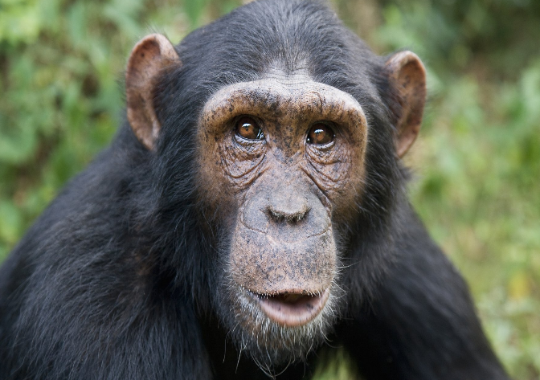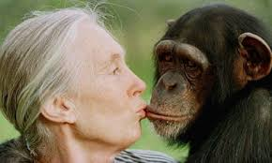

Jane Goodall, a leading British Scientist needs your help…
Her wealth of knowledge about Chimpanzees is amazing and with her lifelong passion in studying these animals has found the species is in decline.
Jane has found with her time in the Gombe National Park, (Africa) that chimpanzees are reducing in numbers due to poachers, lots of deforestation, disease and war zones in the area.
We want to STOP this from happening and save this endangered species.
ANY DONATIONS WELCOME
To make a donation you can text the word CHIMP to 70021. The text will cost you £5 + your network charge (Please ask the bill payers permission if under 18). Your donations will help Jane and your helping to
SAVE THE CHIMPANZEES

STATUS: Endangered
POPULATION: 170,000-300,000
SCIENTIFIC NAME: Pan troglodytes
HEIGHT: 170cm
WEIGHT: 40-60kg
HABITAT: West Africa

ALL DONATIONS MATTER!!

