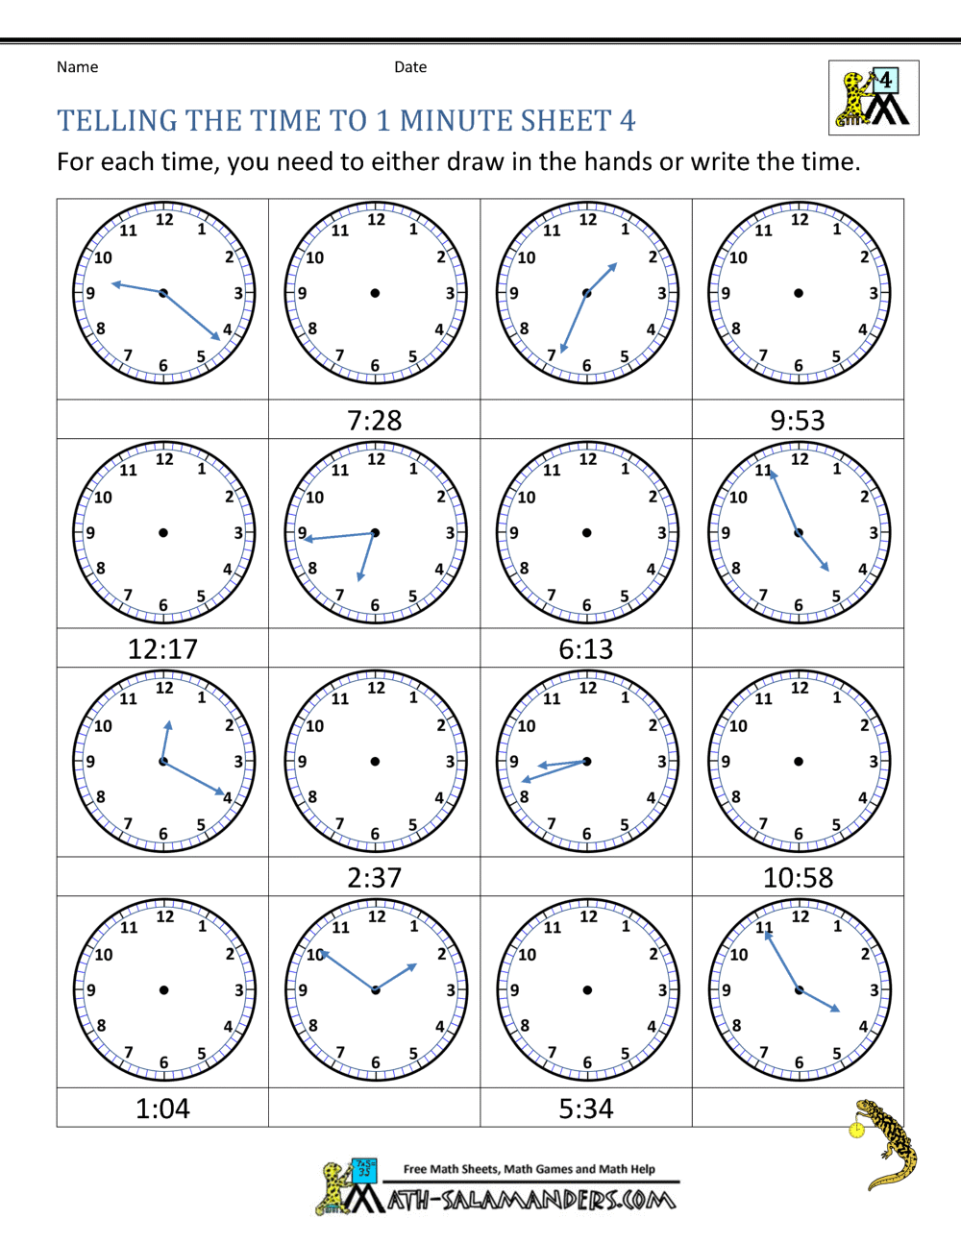

**09:22 or 21:22**

**1) Write the times underneath each clock using digital time.**

**2) What time would it be using 24-hour time if it was 'pm' *(The first one is done for you!)***

***3) Draw the hands on the clock when the time has been given to you.***

**3) Read these times to yourself in words.**

**Maths - Monday - Reuben Ruby, Jack, Cassie, Malachai and Elizabeth**

(See bottom of sheet for instructions)