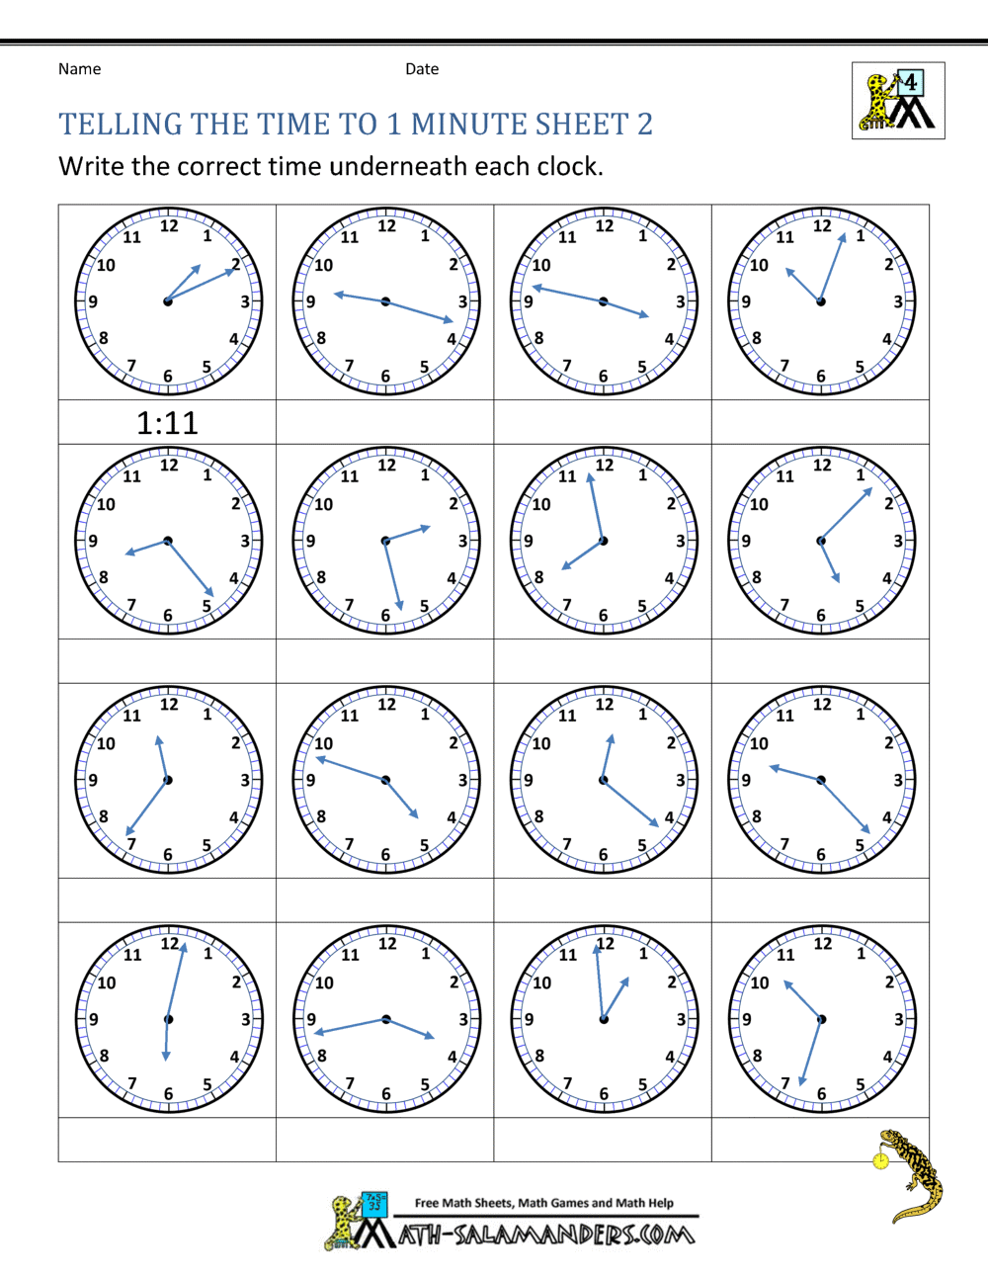

**1) Write the times underneath each clock using digital time.**

**2) What time would it be using 24-hour time if it was 'pm' *(The first one is done for you!)***

**3) Read these times to yourself in words.**

**01:11 or 13:11**

**Maths - Monday - Megan, Henry, Harvey, Bethany and Lily**

(See bottom of sheet for instructions)