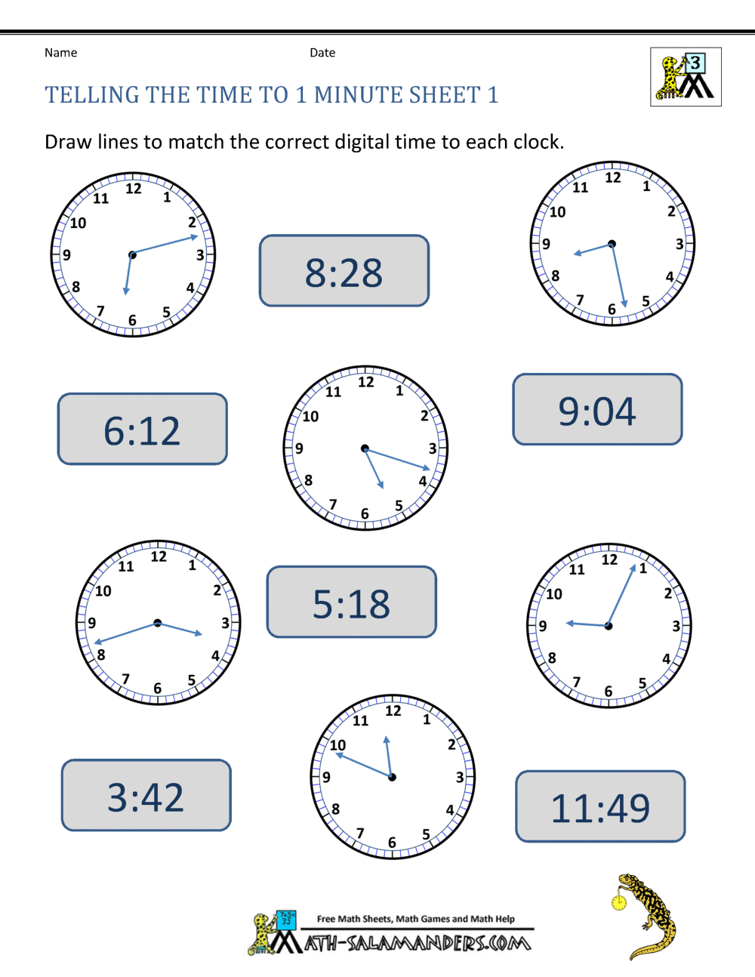

**Maths - Monday (Toby, Zac, Chloe and Dante)**

See bottom of sheet for instructions.

Match these times on the clock faces to their digital time by drawing lines.

If each time was 'pm', underneath each digital time, write the time using 24-hour digital time.

How would you write each of these times in words only?