 | Human | 4O WEEKS
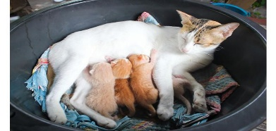 | CAT | 54 TO 63 DAYS.
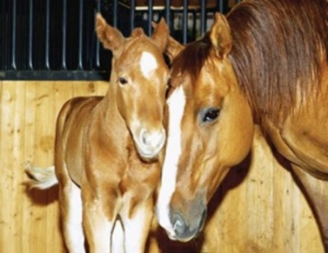 | HORSE | 11 MONTHS
 | DOG | 63 DAYS
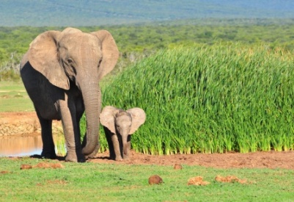 | ELEPHANT | 22 MONTHS
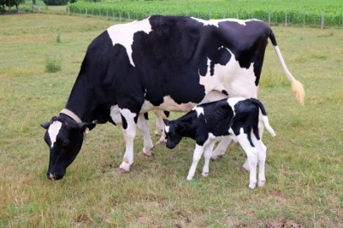 | COW | 283 DAYS
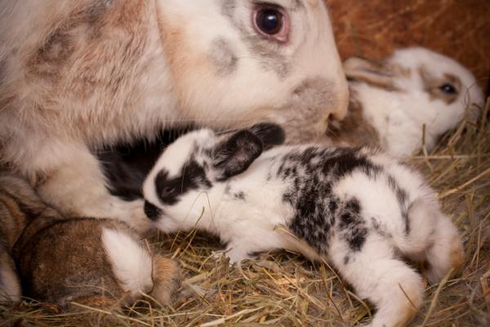 | RABBIT | 27 DAYS
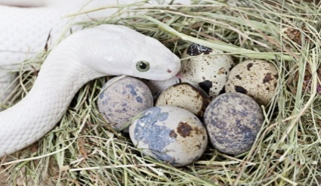 | SNAKE | 27 TO 45 DAYS
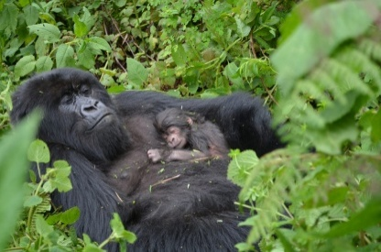 | GORILLA | 257 DAYS
GESTATION IS THE TIME IT TAKES FOR A BABY MAMMAL TO BE MADE IN IT’S MOTHERS TUMMY
I FOUND, THAT GENERALLY, THE BIGGER THE MAMMAL THE LONGER THE GESTATION PERIOD.
SMALL MICE TAKE ONLY 19 DAYS AND ELEPHANTS TAKE ALMOST TWO YEARS!
TWINS TAKE LESS TIME THAN SINGLE BABIES .

