Zeus and the Lightning Strike
(A Greek Myth by Henry Burns)
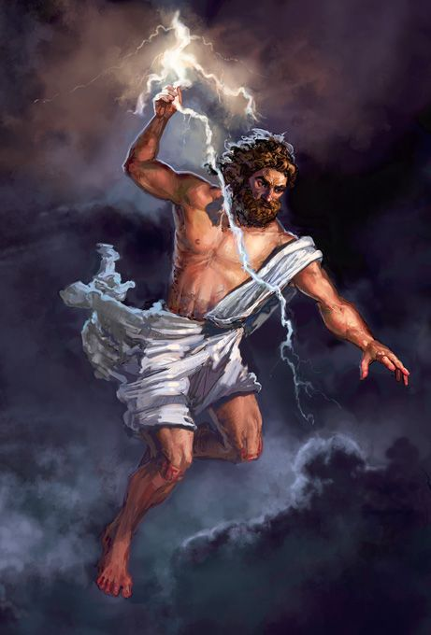

It is said that in the olden days, the land was full of trees that covered the earth. Branches were full and lush with all different colours of green leaves during the spring and summer months. Nature ran through the land and birds could be heard from miles around.
In Myddlewood, (one of the most tranquil places on earth) lived Odysseus. Each day he set out from home to cut trees for firewood for himself and to sell to the local villagers. Odysseus could not believe how lucky he was to live and work in such a beautiful place. He was happy in his job.
Whilst working out in the forest one day, Odysseus was chopping away at the trees. He would cut a tree down and then set about chopping it into smaller logs which would be sold to the villagers for heating and cooking. Odysseus often stopped to look at the trees and plan which way they would fall once he took an axe to them. One of the trees fell in the wrong direction and hit a very large rock. The rock was unsettled and was moved. The rock revealed a large dark, cold and gloomy cave. Odysseus was scared of the dark and what he might find within the cave.
Carrying on with his work, Odysseus did not look any further into the cave. After a while, he started to hear noises coming from the deep dark cave. Turning his body around very slowly towards the entrance, he saw what could only be described as a big shadow that in his mind looked like a monster. Feeling very scared, he was not sure if he was brave enough to go in and see what it was. Getting closer and taking a match from a box in his pocket, he lit a piece of rag from the floor. Holding it up, he was able to see what was an ugly, strong and most of all nasty creature. The creature was called a Minotaur. He had two big horns on the top of his head, which looked like a bull and the strong muscular body of a human. It was a nasty sight!
Odysseus was not brave enough to fight the Minotaur himself, however, he knew of a God that might be able to help him with the situation. This god - named Zeus - was the god of the sky and King of Mount Olympus. His temper was affected by the weather. Odysseus could not think of anybody else who might have been able to help him. He dropped to his knees and prayed to Zeus asking for help.
The sky started to change from a bright sunny day to almost darkness in minutes. Cloud covered over and flashing lights made the sky a purple, red and orange colour. Had Odysseus prayers been answered? Everyone in Myddlewood would have wanted to know what it was.

Odysseus said “Zeus you mighty god, please help me with this creature, I am not powerful enough to fight him off and save the villagers of Myddlewood.”

In a roaring voice Zeus replied, “I shall help you. My powers are mighty and, as you work so hard and want to protect the other villagers, I can send my lightening powers down to slay this monster”.

Zeus was a powerful, amazing and most of all a brave God. He was not scared of anything. His main power was to control the weather and many times had used a lightning strike in order to protect people who worshiped him.
From the colourful sky, through the clouds a shadow appeared the outline of a head and shoulders, it could only be Zeus. By this time, the Minatour creature had emerged from the cave. Looking a little blinded in his eyes he tried to see where Odysseus was.
Odysseus was hiding behind some trees that he had just chopped down, holding the axe in his hand ready to hit the Minatour should he need to. He was very scared. The Minatour had not seen the sky and what was coming; he had not seen Zeus ready to attack from above. A battle was about to commence.
With dust flying and trees being bashed down, the Minatour started running towards Odysseus. Strong and mighty, he wanted to eat him. Zeus then, from the sky threw down a bolt of lightning. It hit a tree and set it on fire, just missing the Minatour. Surprised by the actions from Zeus, the Minatour turned around to see Zeus in the Sky. Unsure what to do, he froze on the spot. Zeus knew that with one strike the Minatour would be gone. Zeus gave out a mighty roar and threw down another piece of lightning and that was it - the Minotaur was gone. Odysseus came out from his hiding place and again got down on his knees with his hand praying towards Zeus.

“How can I ever thank you enough for what you have just done for me and the villagers of Myddlewood?”

Zeus replied “You are very welcome all I ask is that you and the villagers stay alert, stay safe and protect one another.”
The End

