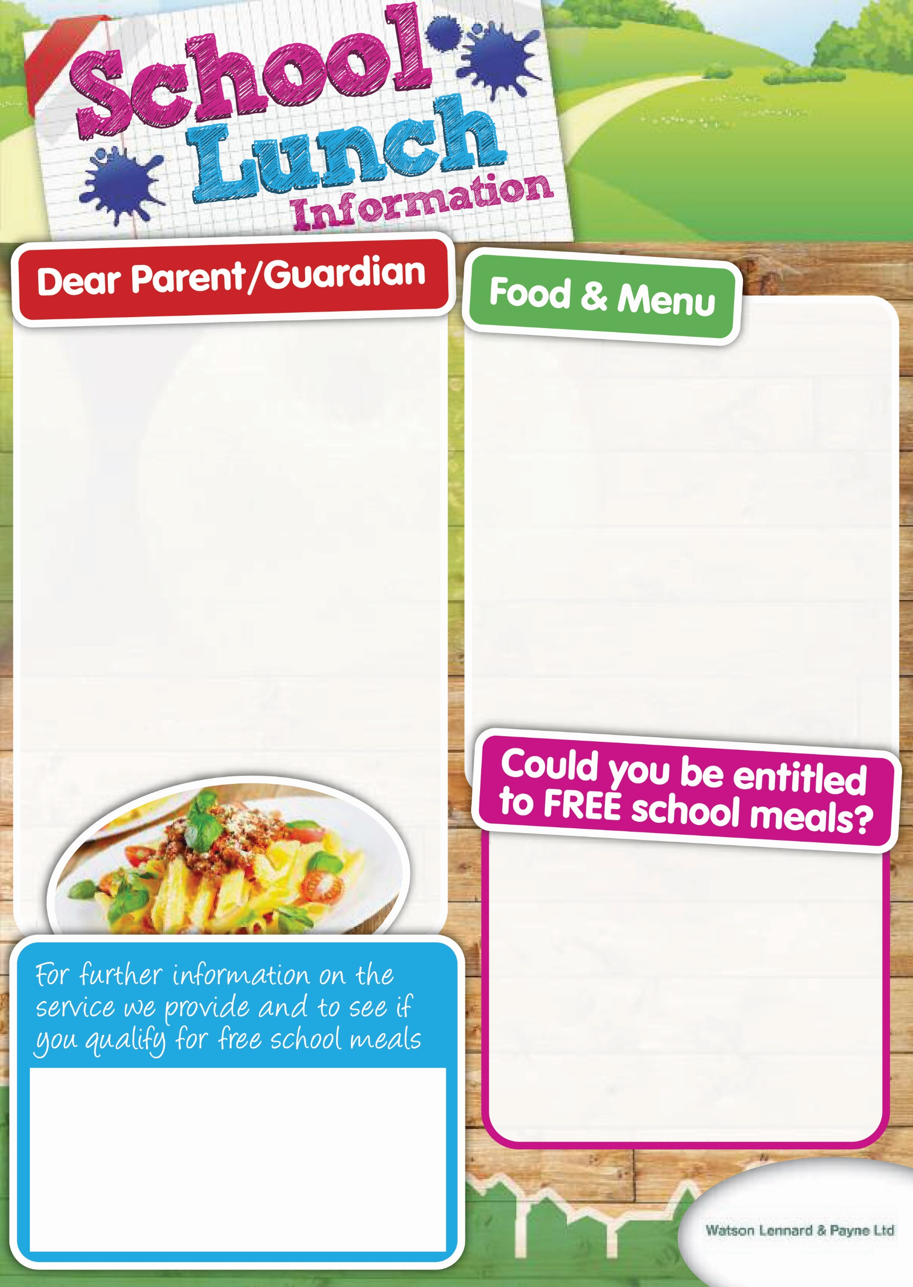

***Myddle Primary School***

***Lunch Menu***

***2019***

*Welcome back to Myddle Primary School. Once again we would like to share with you some of the exciting things that we have planned for the lunch service! Sara Russell our Cook and her team have put together a new set of menus for the New Term, featuring many of the pupils’ favourite dishes along with some new seasonal variations. We would like to build on the success of Universal Infant Free Meals for Key Stage 1 pupils and hope that those pupils who have moved into Key Stage 3 will continue to support the School’s catering service by purchasing a meal. We believe that this is still excellent value at just £2.20 a day.*

***School Food Based Standards***

*Our menus are carefully planned to comply with The School Food Based Standards introduced in January 2015. The Catering Team have vast experience and are constantly trying to innovate and alter our menus to keep them exciting and tasty for your child to enjoy. The Myddle Team are passionate about serving high quality , locally sourced ingredients in our 5 star hygiene rated kitchen.*

*We are able to cater for pupils who may have special dietary needs and Allergen information is available on request.*

*We have printed a copy of our new menus on the reverse of this newsletter and we welcome your comments and children’s feedback this term.*

If you claim certain benefits or have a household income below the Government threshold, you could qualify for Free Meals it is important that even if your child is entitled to the UIFSM you still complete the application for Free Meals .

Please speak to a member of the school staff or

Visit: www.shropshire.gov.uk/**free**-**school**-**meals**/or call**: 0345 678 9000** for more information

School Office Tel: 01939 290834

Email: admin@myddle.shropshire.sch.uk



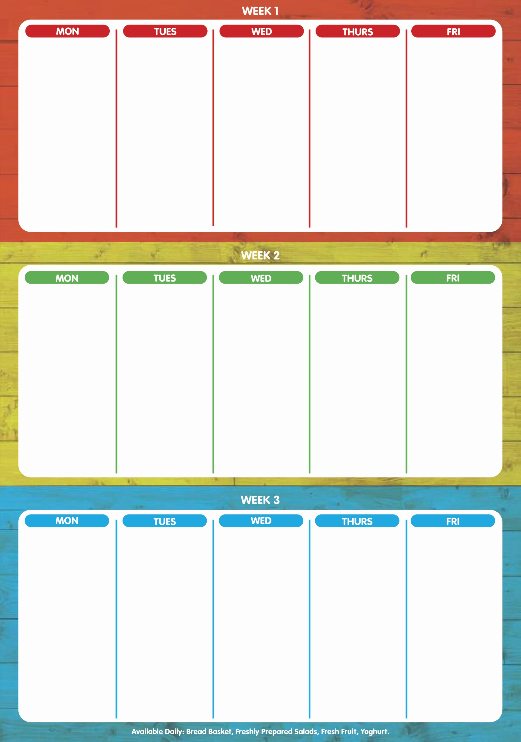

**WEEK 1 – 6th May, 3rd June, 24th June,15th Jul, 9th Sept. 30th Sept, 21st Oct 2019**

Selection of Assorted Pizza (v)

*

Chicken Tender Fillets

****

Chips

Baked Beans

Peas

Sweetcorn

****

Fruit Jelly

Assorted Muffins

Fruit Platter

****

Sausage and Mash

*

Vegetarian Bolognaise (v)

*

Fish Finger Wrap

****

Spaghetti

Baby Potatoes

Carrots

Baked Beans

****

Rice Pudding with Raspberry Coulis

*

Cookie

****

Roast pork, Apple Sauce & Gravy

*

Cauliflower & Broccoli Bake(v)

****

Roast Potatoes Creamed Potatoes

Carrots

Broccoli

Leek & Sweet potato Bake

****

Flapjack with Milkshake

****

Build your own Burger

*

Pasta Neapolitan(V)

****

Jacket Wedges

Sweetcorn

Green Beans

****

Chocolate Chip Cookie

****

Selection of Fish

*

Vegetarian Sausage, Yorkshire Pudding & Gravy (V)

****

Creamed potatoes

Baked Beans

Peas

***

Iced Sponge with Custard

****

WEEK 2 – W/C 13th May, 10th June, 1st July, 16th Sept, 7th October 2019

Meatballs with Freshly made Tomato Sauce

*

Country Vegetable Bake (v)

****

Herby Diced Potatoes

Pasta

Broccoli

Baked Beans

****

Cookie & Milkshake

****

Roast Beef, Yorkshire Pudding & Gravy

*

Vegetarian Sausage Casserole (v)

****

Roast and Creamy Mashed Potatoes

Carrots & Cabbage

Cauliflower

****

Chocolate Sponge with Chocolate Sauce

****

Chicken Korma

*

Vegetarian & Dairy Free Burger Bake

****

50/50 Brown & white Rice

Baby Potatoes

Peas

Sweetcorn

****

Raspberry Swirl with Custard

****

Assorted Pizza (v)

*

Gammon Steak with Pineapple

****

Chips

Sweetcorn

Baked Beans

****

Assorted Fruit Muffins

Frozen yoghurt

****

Sausage & Mash

*

Fish Cake or Fish Fillet

****

Rice

Creamed Potatoes

Peas

Carrots

****

Fruit jelly sundae

*

Cheese & Crackers

****

**WEEK 3 – W/C 29th April, 20th May, 17th June,8th Jul,3rd Sept,23rd Sept, S**

Butcher’s Pork Sausage

*

Vegetable & Herb Plait (V)

****

Creamed Potatoes

Jacket Wedges

Baked Beans

Broccoli

****

Apple Crumble with Custard

****

Sausage Roll

*

Macaroni Cheese with Garlic Bread (V)

****

New Potatoes

Sweetcorn

Green Beans

Spaghetti Hoops

****

Marble Cake Slice

****

Assorted

Pizza (V)

*

Minced Beef & Potato Gratin

****

Chips

Carrots

Sweetcorn

***

Selection of Vanilla & Chocolate Cupcakes

***

Roast Chicken, Stuffing and Gravy

*

Cheese, Potato & Onion Pasty

****

Roast and Creamy Mashed potatoes

Carrots & Peas

Cauliflower Cheese

****

Cookie with Milkshake

*

Ice Cream

****

Beef Fajitas

*

Quorn & Vegetable Fajitas(V)

*

Fish Fingers

****

Herby Diced Potatoes

Minted Peas

Chunky Coleslaw

****

Ginger & Orange Sponge with Custard

****