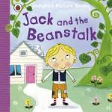

The sound of the week is: i

Please bring in an object that begins with this sound.

Perhaps you would like to have a look at Mr Thorne does phonics with your child

<https://www.youtube.com/results?search_query=mr+thorne+does+phonics+episode+i>

Our Topic is: Homes and Houses

Our Theme is: Traditional Tales

The colour of the week is—

Please bring in an object that is this colour

The number of the week is

3

The story of the week is -

Next week in Snow Leopards:

Week beginning 14th January 2019