

The sound of the week is:

r

Please bring in an object that begins with either of these sounds.

Perhaps you would like to have a look at Mr Thorne does phonics with your child

<https://www.youtube.com/watch?v=0xFKC8tNdEo>

Our Topic is: Homes and Houses

Our Theme is: Traditional Tales

The colour of the week is—



Please bring in an object that is this colour

The number of the week is

4

The story of the week is –

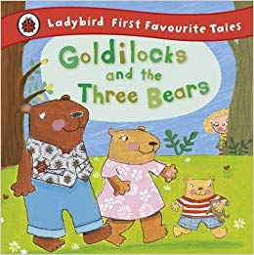

Next week in Nursery:

Week beginning 21st January 2019