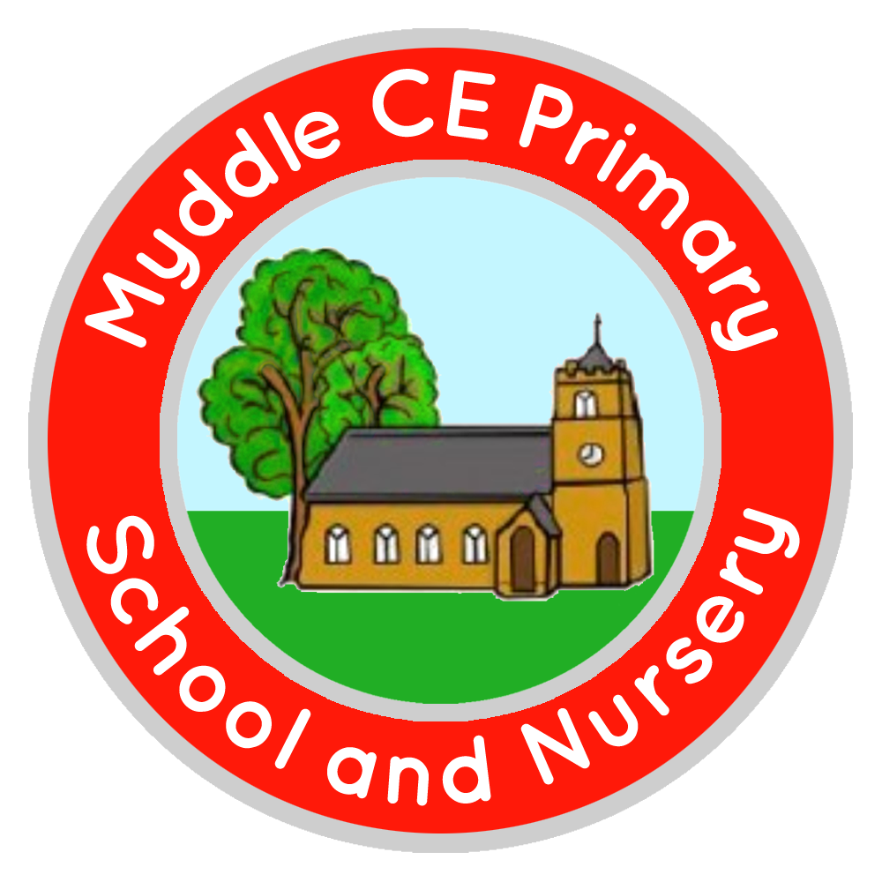
Myddle C.E Primary School and Nursery
Myddle
SHREWSBURY, SY4 3RP

Telephone: 01939 290834
e-mail: admin@myddle.shropshire.sch.uk
www.myddleschool.org.uk

Executive Headteacher Mrs C Williams

‘Growing, learning and living in the love of God’



25th September 2018
Dear Parents/Carers
Year 3/4/5/6 - Young Voices – Thursday 17 January 2019
Myddle CE Primary is very excited to be taking part in the Young Voices concert at Birmingham Genting Arena next January. The children will join with other schools from all over the country for an afternoon rehearsal before performing an evening concert.
Young Voices concerts are an amazing event to be involved with as thousands of children gather together to sing with live musicians, famous artists and with each other in front of thousands of friends and family. It is a great opportunity for your child to be involved in an event that they will remember for many years. More information can be found at www.youngvoices.co.uk where you will find the words and music for some of the songs.
Children will need to come to school at the normal time. We will leave at approximately 12.00pm to enable us to attend the afternoon rehearsal. The concert commences at 7pm and ends at around 9.15pm. We will bring children back by coach arriving in school at about 11.00pm. It is a long day but very rewarding. The following day children will not be required to start school until break time at 10:30am.
We need to register children with Young Voices by Friday 28 September. If you would like your child to take part please complete the slip below and return it to school by Friday.
Parents are very welcome to come to the concert. Tickets can be ordered directly through school, that way we can try to ensure you are seated in the arena opposite your child. A letter with more information will be sent home nearer the time.
Yours sincerely
C Williams
Mrs C Williams
Executive Headteacher
-----------------------------------------------------------------------------------------------------------------------
Year 3/4/5/6 - Young Voices 2019
I would like my child ______________________________________to attend Young Voices concert at Birmingham Genting Arena on Thursday 17 January 2019.
Signed__________________________________Parent/Carer

